=

Data Security Envisioning Workshop
00-Master Delivery Guide
v8.5 - January 2026
Contents
Disclaimer 4
Version history 5
1 Introduction 7
1.1 About the Data Security Envisioning Workshop 8
1.2 Qualification criteria for engagement funding 9
1.3 What is the Data Security Check? 9
1.4 What are the Data Security Check optional modules? 11
1.5 The Microsoft Purview portfolio overview 12
1.6 The Recommendations and next steps activity 12
1.7 Data confidentiality and information privacy 12
1.8 Reading guidance 13
1.9 Intended audience 13
2 Data Security Envisioning Workshop-Overview 14
2.1 On-site vs. remote delivery 14
2.2 Delivery schedule 14
2.2.1 Week 1-Prepare for delivery 15
2.2.2 Week 2-Configure and enable Automated Discovery 16
2.2.3 Week 3-Automated Discovery continues 17
2.2.4 Week 4-Analyze, report, and workshop 17
2.3 Estimated partner effort-Data Security Envisioning Workshop 18
2.3.1 Detailed estimates - Data Security Check - MANDATORY scope 19
2.3.2 Detailed estimates - Data Security Check - OPTIONAL Scope 20
2.4 Resource requirements 21
2.4.1 Recommended roles per activity 22
2.5 Targeted customers 23
3 Pre-engagement meeting 24
4 Data Security Check 27
4.1 Objectives 28
4.2 Scoping 28
4.3 Customer requirements 29
4.4 Infrastructure requirements 30
4.5 Deliverables 31
4.6 Automated Discovery tools and services 32
4.7 Sensitive Info Types 32
4.8 Impact on user experience 33
4.9 Step 1 - Kick-off meeting 34
4.10 Step 2 - Acquire and assign licenses 36
4.11 Step 3 - Setup and configuration 38
4.11.1 Assign Data Security Check team members the required permissions 38
4.11.2 Define search artifacts for Automated Discovery 40
4.11.3 Turn on audit log recording for user and admin activities 48
4.11.4 Create eDiscovery Case 49
4.11.5 Additional per module guidance 49
4.12 Step 4 - Analyze the findings 50
4.12.1 Additional, per module guidance 52
4.13 Step 5 - Report and recommendations write-up 52
4.13.1 Results and Findings report 53
4.13.2 Recommendations for risk mitigation 54
4.14 Step 6 - Decommission 55
5 Microsoft Purview portfolio overview 58
6 Recommendations and next steps 61
Appendix A - Formatting CSV files in Excel 62

Disclaimer
The Data Security Envisioning Workshop provides a summary of an organization’s data protection and compliance stature and recommendations to improve data protection and compliance.
The information, results, and scoring provided through the Data Security Envisioning Workshop are recommendations and provided for general informational purposes only. They do not constitute legal advice, certifications, or guarantees regarding regulatory compliance; it is up to each organization to evaluate the effectiveness of these recommendations in their respective regulatory environment prior to implementation. Organizations should consult with their own legal professionals to determine how standards or regulations apply to their organization and how to best ensure compliance.
We hope the Data Security Envisioning Workshop helps identify technologies and additional steps that organizations can implement to simplify their compliance efforts.
MICROSOFT MAKES NO WARRANTIES, EXPRESS, IMPLIED, OR STATUTORY, AS TO THE INFORMATION IN THIS Data Security Envisioning Workshop. Microsoft disclaims any conditions, express or implied, or other terms that use of the Microsoft products or services will ensure the organization’s compliance with regulations or standards. This Data Security Envisioning Workshop toolkit is provided “as-is.” Information and recommendations expressed in the Data Security Envisioning Workshop toolkit may change without notice.
The Data Security Envisioning Workshop toolkit does not provide the user with any legal rights to any intellectual property in any Microsoft product or service. Use of the tool is for internal, reference purposes only; however, Microsoft partners may distribute the Data Security Envisioning Workshop toolkit to their customers for such customers’ internal, reference purposes only. Any distribution of the Data Security Envisioning Workshop toolkit by a Microsoft partner to its customers must include terms consistent with those set forth in this disclaimer.
© 2026 Microsoft. All rights reserved.

Version history
Version | Author | Changes | Date
1.0 | François van Hemert | First published v1 release | November 2019
2.0 | François van Hemert  Wayne Anderson | First published v2 release | June 2020
2.1 | François van Hemert | Maintenance release, minor updates  Includes Custom Sensitive Types update | November 2020
3.0 | François van Hemert | Introduced modular design, added Compliance Manager and Data Loss Prevention for Endpoints module | January 2021
3.1 | François van Hemert | Added Data Loss Prevention for Teams module | February 2021
4.0 | François van Hemert | Workshop split, update to align with new narrative, rebranding, updates to guidance and organized around data repositories. | June 2021
4.1 | François van Hemert | Update with Compliance Manager Premium Assessments | October 2021
4.2 | François van Hemert | Purview branding update, step-by-step guidance update to align with changes M365 | July 2022
4.2.1 | François van Hemert | Updated Microsoft Compliance Configuration analyzer to Configuration analyzer for Microsoft Purview | July 2022
4.2.2 | François van Hemert | Update to align with current product features and functionality (evergreen) | January 2023
6.0 | François van Hemert | Workshop merge, align with FY24 solution play, focus on Data Security. | August 2023
6.5 | François van Hemert | Update step guidance, align with FY25 solution play | July 2024
6.6 | François van Hemert | Update to align with the new Microsoft Purview Portal | October 2024
7.0 | François van Hemert | Added Data Security for AI optional module | January 2025
7.1 | François van Hemert | Updated Content Search guidance to align with new eDiscovery experience | May 2025
8.0 | François van Hemert | Update to align with current product features and functionality (evergreen), update name, update branding. | July 2025
8.5 | François van Hemert | Update to align with current product features and functionality (evergreen) | January 2026

We look forward to your feedback!

Thank you for your continued trust and partnership. The resources within this toolkit will be iteratively improved upon based on product releases as well as direct feedback from delivered engagements. We encourage you to provide feedback to help us improve our products and toolkits.
Please share your feedback and questions via our Engagement feedback form that can be found at: https://aka.ms/SCIEngagementsFeedback.

Introduction
Data is vital for every business. IDC forecasts that the datasphere will double in size by 2026. Data will be ubiquitous and will keep growing exponentially in the future. Data generates insights that help run businesses, provides a competitive edge in the market, and enables employees to work together and stay efficient.
Today, data is used beyond the normal boundaries of business. Data is stored on-site, in multiple clouds, on devices, and more. It is being accessed from within and outside the corporate networks.
With the fast adoption and deployment of generative AI apps, more data will be produced at a faster rate. The risks involved in using and launching generative AI apps are not yet fully known and because of this they are increasing the demand for securing and governing the data input and output.
With this increase in data, data security incidents are common and rising, costing organizations millions of dollars every year to resolve.
Our customers need to secure and manage their data, but they often find it a complex and multi-faceted challenge.
Securing data is becoming harder as the data and its sources multiply - different kinds of data need different levels of protection. Applying general policies without knowing what data you have is not an efficient approach. It is estimated that about 30% of decision makers are unaware of the location or nature of their sensitive business-critical data, lacking full visibility in their digital estate.
Data does not move itself; people move data – it is important that organizations understand how data is being used and shared in their organization. Every organization has different kinds of data, different kinds of users, and they have different goals they want to achieve – there is no one size fits all strategy.
Organizations need to first understand the data security risks they face – this starts with getting visibility into what data they have, where it is stored and how their users are interacting with that data. Without this visibility, it is not possible to effectively protect the data.
This document contains delivery guidance for the Data Security Envisioning Workshop. The workshop will help customers understand data security risks related to their organizational data and offers a structured approach to mapping these risks to Microsoft Purview solutions that can help reduce the identified risks while managing and protecting their data.

Sources:
- Microsoft Data Security Index report
- First Annual Generative AI Study: Business Rewards vs. Security Risks, Q3 2023, ISMG, N=400
- March 2023 survey of 510 US compliance decision makers commissioned by Microsoft from agency Vital Findings
- Gartner, Security Leader’s Guide to Data Security, ​Andrew Bales, Sep 2023

About the Data Security Envisioning Workshop
The Data Security Envisioning Workshop is a workshop delivered by Microsoft partners, Microsoft field, or Microsoft Global Partner Solutions (GPS) and its goal is to help land the value proposition of Microsoft Purview with customers’ business decision makers.
The workshop is built around a modular concept and provides delivery teams the option to add optional modules based on customer requirements and needs. The illustration below provides a high-level overview of both the mandatory and optional modules.
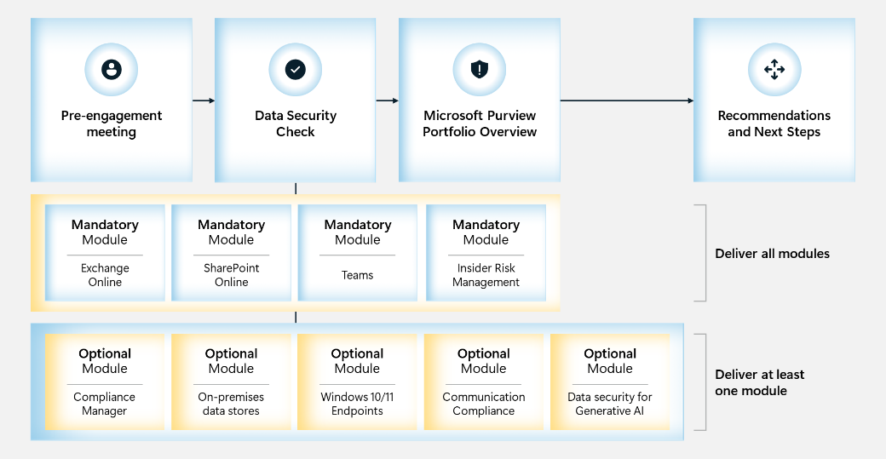
The activities will help customers assess their data security, privacy, and regulatory requirements; address their most pressing data security goals and challenges; and provide an immersive experience that brings to life Microsoft’s vision and capabilities with respect to data security, privacy and regulatory compliance.
The objective for the Data Security Envisioning Workshop is to help customers understand how Microsoft 365 services and products can mitigate and protect against data security risks.
The Data Security Envisioning Workshop is powered by the Data Security Check. The Data Security Check is a structured activity that leverages a subset of Microsoft Purview products, services, and features to gain visibility into existing, and sometimes hidden, data security risks that may exist in the data that resides in the customer’s Microsoft 365 production environment. In addition to identifying data risks, the Data Security Check will also evaluate user behavior for risky activities that might impose risk to the organization. The outcome and findings of the Data Security Check serve as input to the overall workshop and will be used to create awareness and identify potential areas for mitigation.

Qualification criteria for engagement funding
Partners delivering the Data Security Envisioning Workshop that want to qualify for the associated funding need to meet the overall qualification criteria as outlined on the customer nomination website. These partners must successfully deliver the following:
- All Data Security Check mandatory modules.
- At least one of the Data Security Check optional modules:
  - Compliance Manager
  - On-premises data scanner
  - Windows Endpoints
  - Communication Compliance
  - Data Security for AI
- The Microsoft Purview portfolio overview
- The Recommendations and next steps session.
Additionally, the partner can opt in to delivering one or more of the other Data Security Check optional modules.

 Important
The delivery partner is free to decide on the modules delivered to the customer. However, failing to deliver any of the mandatory modules and at least one optional module will disqualify the delivery partner for the funding associated with the Data Security Envisioning Workshop.

At the conclusion of the Data Security Envisioning Workshop, both the customer and the delivery partner are required to complete and submit an online survey. Microsoft will review the submitted surveys for completeness and validate their content. The partner will only be eligible for funding associated with the workshop if both surveys are fully completed and accurate.

What is the Data Security Check?
The Data Security Check is an integral part of the Data Security Envisioning Workshop. The Data Security Check leverages Microsoft Purview tools and services in an automated process to:
- Discover data that is stored in the Microsoft 365 Cloud and analyze it for the presence of artifacts that may impose data security risks to the organization.
- Analyze user behavior for events that impose a risk to the customers organization. These vulnerabilities include, but are not limited to, the loss of intellectual property, workplace harassment, oversharing of (sensitive) data, and the use of generative AI applications.
The Data Security Check is structured around typical Microsoft 365 services and their associated data repositories that organizations use. At its core, the Data Security Check analyzes user behavior and scans data repositories related to email, collaboration, and document storage. Optional modules can be added to extend the Data Security Check to include on-premises data repositories, Windows 10/11 endpoints, generative AI usage and more. All activities share a common set of activities for setup and configuration, write-up, and decommissioning as depicted in the illustration below.
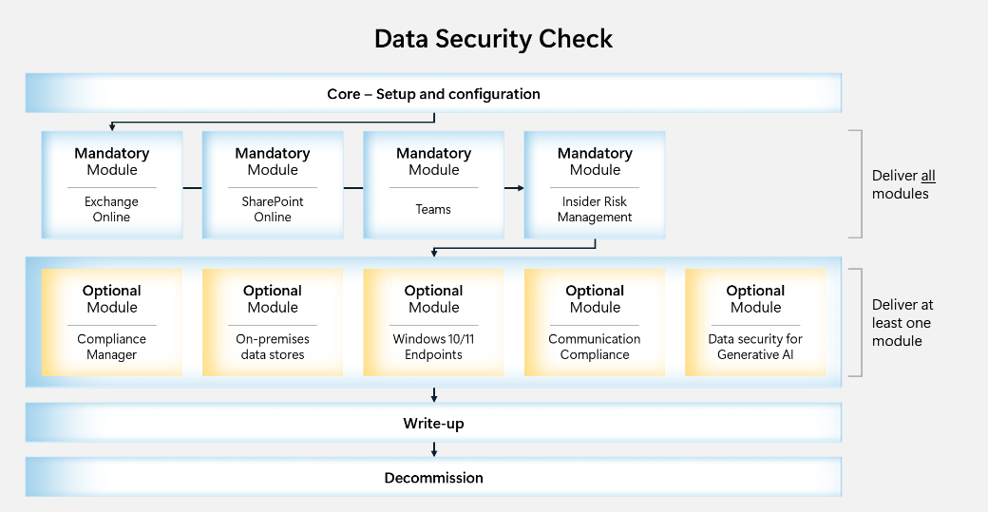
The first activity for the Data Security Check is to enable and configure the tools and services needed for the Automated Discovery of data security risks. The Automated Discovery process will analyze user behavior for risky activity and scan the data stored in the Microsoft Cloud for artifacts that might impose data security risks to the organization. The automated discovery process will run for approximately two to three weeks and will be followed by an analysis of the findings and identified risks. The last step of the engagement will be to present and deliver a set of recommendations that can help mitigate and eliminate the identified risks in the future.
The Automated Discovery process will:
- Scan the existing data for the following artifacts:
- Data that contains one or more sensitive information types
Documents, emails, real-time communication, and other types of data often contain critical information about employees, customers, projects, clients, or other types of business-sensitive content. Most organizations are, or will soon be, subject to one or more privacy or industry regulations such as GDPR, CCPA, SOX, HIPAA, or others. The unintended exposure, breach, or leakage of data containing any kind of sensitive information may potentially bring high financial, reputational, or other risks to the business and should be avoided at all times.
The Automated Discovery process will create an inventory of documents, files, and other types of data containing a variety of sensitive data including Personally Identifiable Information (PII) such as credit card numbers, social security numbers, or personal health information (PHI). Additionally, by leveraging custom search terms, the Automated Discovery process will also search for business intellectual property such as business plans and product designs.
- Stale data
Much of the data that is created by organizations becomes stale or unused immediately after creation and at that time is no longer of value. Most organizations have not implemented an automated retain and delete process to safeguard timely deletion of stale documents or data. This typically results in high volumes of stale and unused data that can impose risks and potential financial liability if consumed by AI or exposed inappropriately.
The Automated Discovery process will create an inventory of data that is older than 12 months and provides insight into the number of individual documents, their size, and location. This inventory can be used to better understand the risks of stale data and may even be used to optimize storage costs in the future by moving stale data to cheaper storage solutions.
- Monitor user behavior for:
- Suspicious and unusual activities
In addition to data discovery and analysis, the Data Security Check will also identify unusual activities involving organizational data such as a high volume of file uploads or downloads, unusual volume of external file sharing, IP Theft, sensitive data leaks or security violations.

What are the Data Security Check optional modules?
The Automated Discovery process focuses on identifying data security risks in data the customer has stored in the Microsoft 365 Cloud and analyzing user behavior for risky activity related to sensitive information. It can be extended by adding optional modules that will enhance the discovery process with capabilities to:
- Assess the customer’s Microsoft 365 environment against the Data Protection Baseline and one or more customer specific assessments that can help the organization comply with national, regional, and industry-specific requirements governing the collection and use of data. (Compliance Manager module).
- Scan on-premises data repositories such as file shares and SharePoint Server libraries. (On-premises data scanner module).
- Detect malicious and inadvertent risk activities on local workstations. (Windows Endpoints module)
- Discover privacy and regulatory risks by evaluating user communication inside the organization. (Communication Compliance module).
- Analyze user access to Generative AI solutions like Microsoft 365 Copilot and third-party AI websites. Highlight issues with shadow AI use, sensitive information exposure, and potential data oversharing. (Data Security for AI module)
The partner delivering the Data Security Check should engage in a dialog with the customer to discuss the optional modules and decide which are relevant to the them and should be included in the Data Security Check scope.

Important
To qualify for the funding associated to the delivery of the Data Security Envisioning Workshop, at least one optional module must be delivered.

The Microsoft Purview portfolio overview
The Microsoft Purview portfolio overview will be delivered as part of the Data Security Envisioning Workshop. During this session, the delivery partner will introduce the customer to the Microsoft Purview vision and outline Microsoft’s approach to providing integrated protection and risk mitigation.
By using the findings from the Data Security Check Automated Discovery, the Microsoft Purview portfolio overview presentation will be tailored to the customer’s situation and provide real life examples of services that can help mitigate data security risks.

The Recommendations and next steps activity
Recommendations and next steps typically is the last activity for the Data Security Envisioning Workshop. During this session the findings and risks that were identified by the Data Security Check are mapped to products and services from the Microsoft Purview portfolio and actionable next steps are defined and presented.
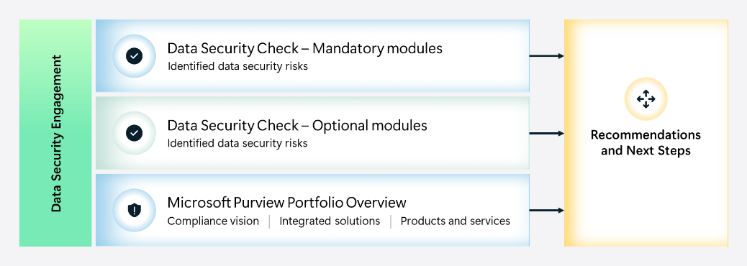

Data confidentiality and information privacy
To safeguard user and data privacy and prevent access to sensitive or personal search results by unauthorized customer or partner staff, inventory data and content identified by the Automated Discovery process is only accessible to authenticated and authorized users who have been assigned the appropriate access privileges. Where applicable, pseudonymization will be used to further protect user privacy. Additionally, all activities involving data or content will be logged and are auditable.

Reading guidance
Delivery guidance for the Data Security Envisioning Workshop can be found in two types of documents:
- 00-Master Delivery Guide (this document)
  - Describes the overall engagement and provides delivery schedules, timelines, and resource requirements.
  - Includes all mandatory activities that are part of the default scope and should be executed for every Data Security Envisioning Workshop delivery.
  - Describes the initial setup and preparation for the various Data Security Check activities.
- 01-Module Delivery Guide-Exchange, 02-Module Delivery Guide-SharePoint, etc.
  - Provide delivery guidance for individual modules that focus on specific Microsoft 365 services such as Exchange Online, SharePoint Online, Teams ,etc.
  - The activities described in the Master Delivery Guide are a pre-requisite to the activities described in these guides and must be completed prior to the start of the activities in the module guides.
For each activity, the delivery guides provide execution guidance and tips, describe resource requirements, and provide links to background documentation while focusing on a successful engagement and valuable outcome.
 Important
Information provided in the delivery guides should be considered as an example on how to deliver the Data Security Envisioning Workshop. It is highly recommended to customize the artifacts in the Data Security Envisioning Workshop toolkit to align with the existing value propositions and the targeted customer’s IT infrastructure.

Refer to the included <_ReadMe - Whats in the Box> document for a complete overview of all documents and supporting collateral included in the toolkit.

Intended audience
This document and all other content contained in the Data Security Envisioning Workshop toolkit are intended to be used by Microsoft field, Microsoft Global Partner Solutions (GPS), and Microsoft partners delivering the Data Security Envisioning Workshop.

Data Security Envisioning Workshop-Overview
The Data Security Envisioning Workshop, powered by the Data Security Check, is an engagement delivered by Microsoft field, Microsoft Global Partner Solutions (GPS), or Microsoft Partners. This workshop assists in communicating the value proposition of Microsoft Purview to customers’ business decision makers.
The engagement is structured around three core activities and preceded by a Pre-engagement meeting to discuss the upcoming activities, resource requirements, and delivery schedule.

On-site vs. remote delivery
The Data Security Envisioning Workshop can be delivered remotely through online meetings or on-site at the customer’s premises. On-site delivery is the preferred delivery method because of the highly interactive nature of the engagement and configuration activities.

Delivery schedule
Typically, the activities for the Data Security Envisioning Workshop will be delivered over a four-week period:
 | Data Security Envisioning Workshop
Week 1 | Prepare for delivery
Week 2 | Data Security Check  - Step 1 - Kick-off meeting  - Step 2 - Acquire and assign licenses  - Step 3 - Setup and configuration  - Automated Discovery
Week 3 | Data Security Check  - Automated Discovery continued
Week 4 | Data Security Check  - Step 4 - Analyze the findings  - Step 5 - Report and recommendations write-up  - Step 6 - Decommission  Microsoft Purview portfolio overview  Recommendations and next steps

The delivery schedule outlined in the paragraphs below provides a sample schedule for the overall Data Security Envisioning Workshop. It does not take additional optional modules into account and is based on the default scope. If the customer chooses to also engage in one or more additional modules, the schedule should be adjusted accordingly.

Week 1-Prepare for delivery
The engagement will start with a remote preparation meeting. This Pre-engagement meeting typically is an online meeting organized one week prior to the actual start of the engagement. During this online meeting, the partner will introduce the customer to the Data Security Envisioning Workshop, discuss the upcoming activities, and decide on the optional modules that will be included. The objective for the online meeting is to align expectations and timelines. For customers that have had no prior exposure to the products and tools that will be used during the engagement, it is possible to include a high-level introduction and demo explaining the features and functionality. The remainder of the first week is intended to be used by the customer to arrange logistics, allocate resources, and prepare for the upcoming delivery.
The illustration below depicts the schedule for the first week of the engagement.
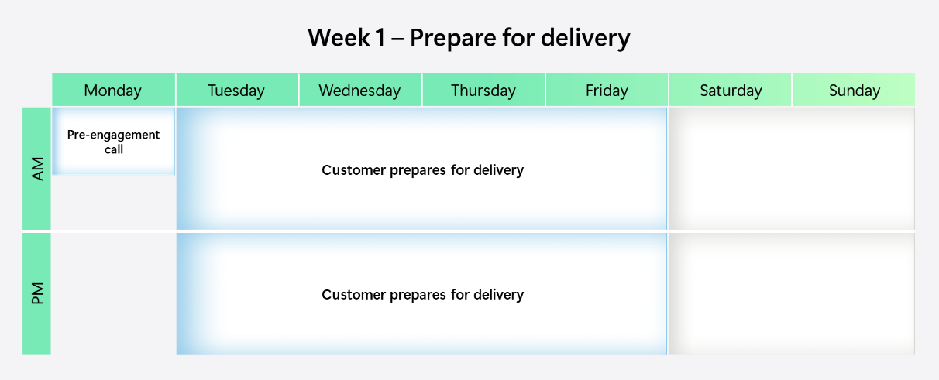

Week 2-Configure and enable Automated Discovery
The second week marks the actual start of the engagement delivery. Together with the customer, the partner will configure and enable the required, and if needed optional, services and tools and start the Automated Discovery for the Data Security Check.
The illustration below depicts the schedule for the second week of the engagement.
Note
The delivery schedules outlined in the paragraphs below are based on the delivery of all mandatory and one optional module of the Data Security Check. If the customer and partner agree on including additional optional modules, the delivery schedule needs to be updated. Refer to paragraph 2.3.2 for an estimation of additional effort that needs to be factored into the schedule.

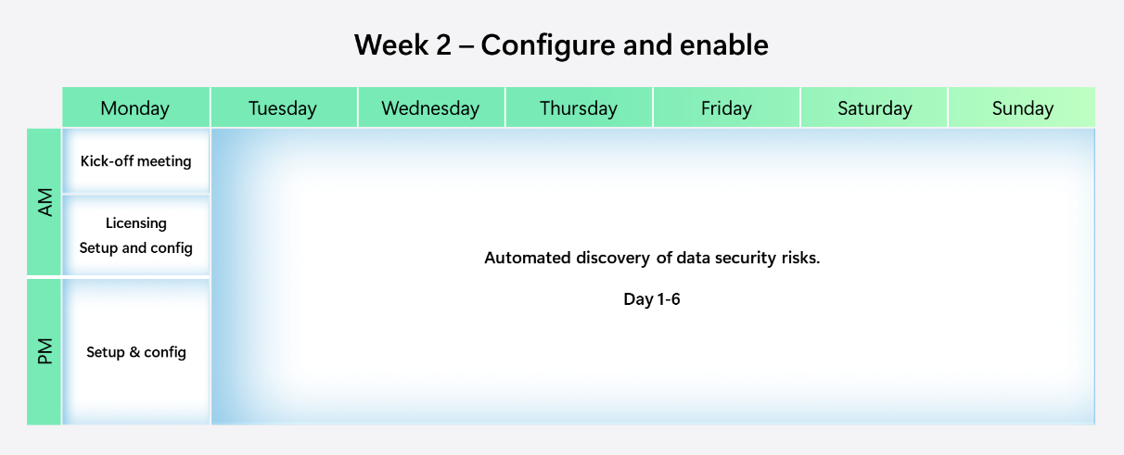

 Important
Allowing the Data Security Check Automated Discovery to run for at least two weeks after enablement is recommended to ensure the results and findings represent a normal production setup. From previous deliveries, we have learned that the Automated Discovery process needs at least two weeks to generate meaningful results.

Week 3-Automated Discovery continues
During the third week of the engagement, the Data Security Check Automated Discovery process will continue to run.
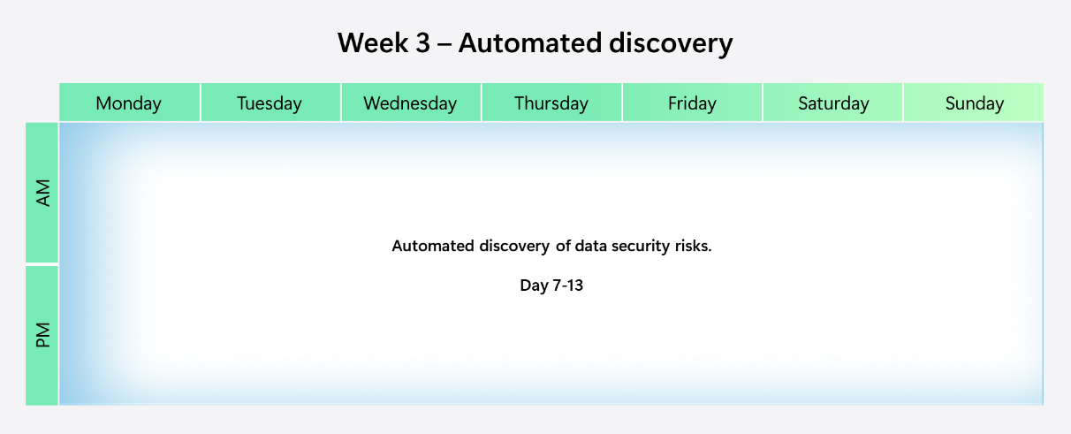

Week 4-Analyze, report, and workshop
The fourth week of the engagement is focused on preparing for the delivery of the interactive components of the engagement. The findings of the Data Security Check Automated Discovery will be collected, analyzed, and mapped to Microsoft Purview solutions for risk mitigation. During the workshop, the findings and identified data security risks will be discussed, possible solutions for mitigation will be presented, and a roadmap with actionable next steps and recommendations will be created.
The illustration below depicts the schedule for the fourth week of the engagement.
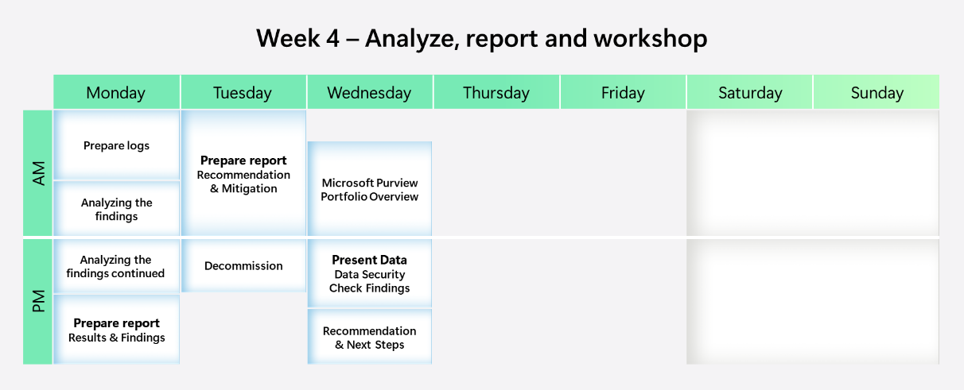

Estimated partner effort-Data Security Envisioning Workshop
The table below provides a high-level estimate of the partner effort required for the Data Security Envisioning Workshop activities as outlined in the previous paragraphs. It does not include any estimates for the optional modules. The effort estimates provided are to be considered as indicative and can change as a result of customization of the delivery schedule, customer specific requirements (e.g., change windows), and the individual activities.
The estimates for the Data Security Check activities are further detailed in the next sections.
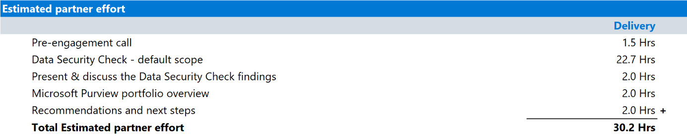

Detailed estimates - Data Security Check - MANDATORY scope
The Data Security Check is an integral part of the Data Security Envisioning Workshop. The table below provides a detailed estimate of the partner effort for the Data Security Check activities but does not include any optional modules. The estimates provided are to be considered as indicative of a typical delivery and can change as a result of customization of the delivery schedule and the individual activities.
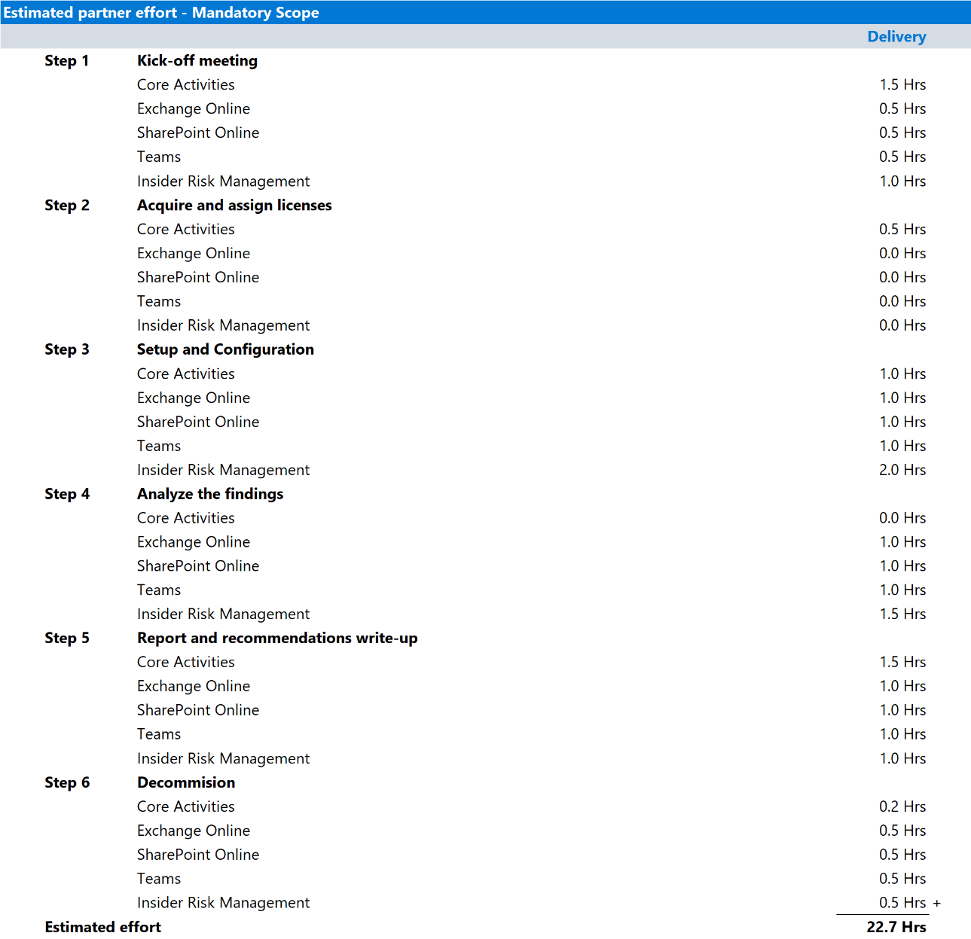

Project/engagement management
The typical effort for the Data Security Check activity is outlined above and based on the sample schedule provided in this document. The estimates do not include time for optional (external) project/engagement management resources. If an (external) Project or Engagement Manager is required, additional hours should be added accordingly.

Detailed estimates - Data Security Check - OPTIONAL Scope
The table below provides a high-level estimate of the additional partner effort for the optional modules that can be included as part of the Data Security Envisioning Workshop. The numbers provided should be considered as indicative of a typical delivery and can change as a result of customization of the delivery schedule and the individual activities.
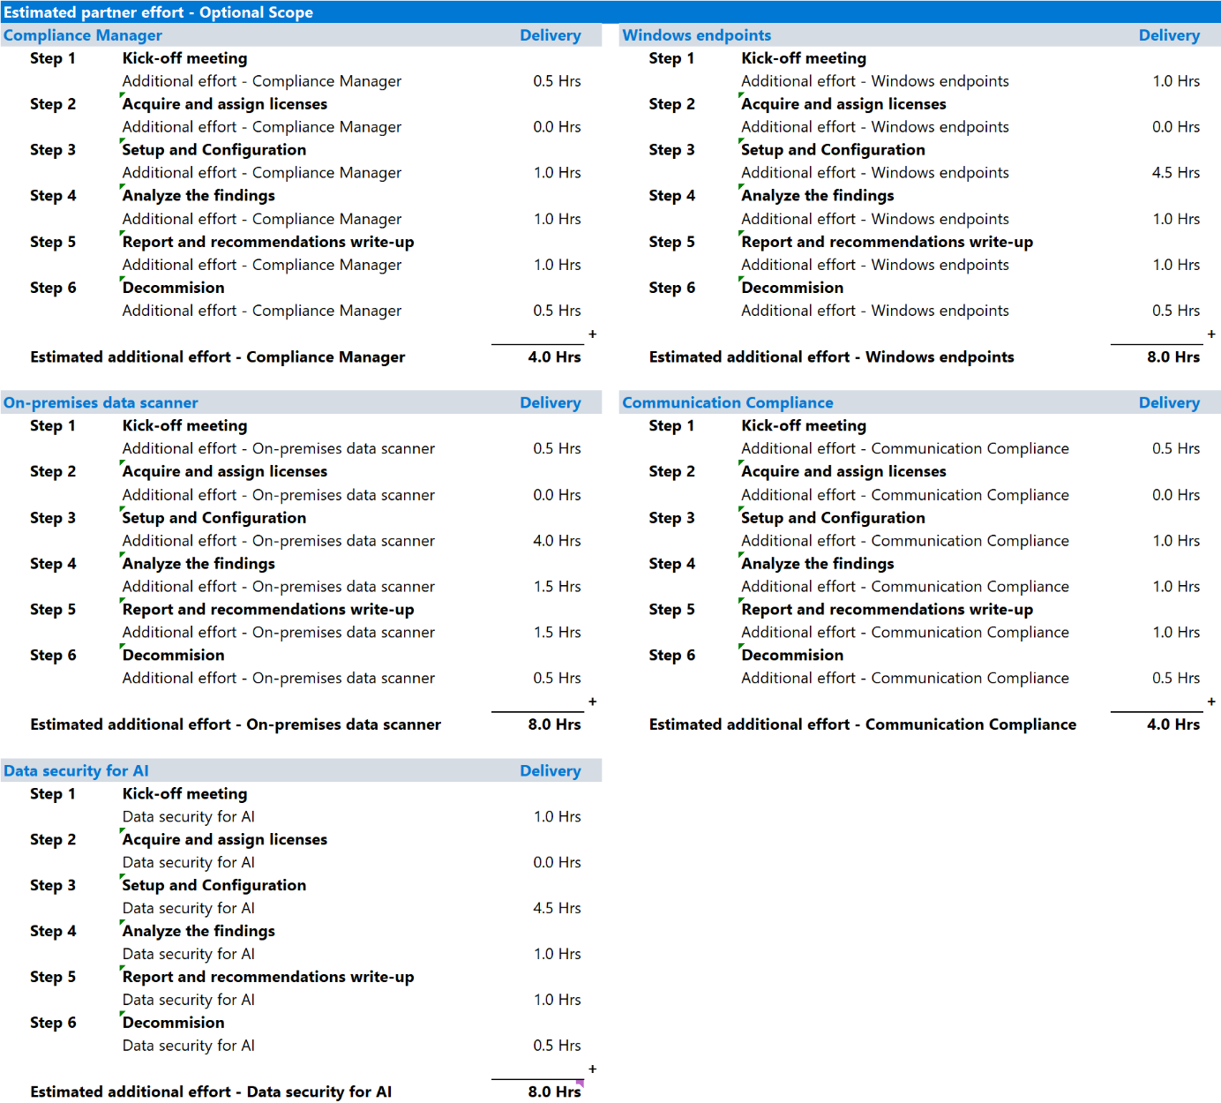

Resource requirements
Having the right people present for the various activities is instrumental to the success of the delivery. The next paragraphs provide suggestions for roles and resources required for the Data Security Envisioning Workshop and the Data Security Check activities.

Note
Depending on the organizational design of your customer, some or all of these roles may be combined or have different titles. Please review the scope of responsibility of the roles and discuss during the Pre-engagement meeting to determine the appropriate stakeholders for the Data Security Envisioning Workshop.

Customer resources
Executive Sponsor
- Owns the business case.
- Keeps project aligned with organization's strategy and portfolio direction.
- Governs project risk.
- Focuses on realization of benefits.
- Provides assurance.
- Suggested candidates: CCO, CSO, CISO, CEO, CFO, CIO, or CTO.
Architects
- IT-Architect - provides overall architectural guidance and insights.
- Compliance Architect - provides architectural guidance and insights into regulatory and privacy policies and standards.
- Security Architect - provides architectural guidance and insights into security policies and standards.
Administrators
- Compliance & Security Administrator - provides technical guidance and insights into currently deployed security, regulatory, and privacy controls.
Tenant Administrators
- Microsoft 365 Tenant Administrator - provides insights into existing use of Microsoft 365 and access to tenant and service configuration.
Project or Engagement Manager (optional)
- Basic understanding of regulatory and privacy policies and standards.
- Basic understanding of data security, data privacy, and security products.
Partner resources - required
Compliance Consultant / Compliance Advisor
- Good understanding of rules, regulations, and standards that are applicable to the customer’s organization.
- Can advise on privacy and regulatory risks and mitigation.
- Understands data security, data privacy, and security products and services.
Partner resources - optional
Project or Engagement Manager
- Basic understanding of regulatory and privacy policies and standards.
- Basic understanding of data security, data privacy, and security products.
- Experience managing regulatory engagements.
Security Consultant
- Strong cybersecurity background and knowledge.
- Good understanding of Microsoft 365 and the security components of Microsoft 365.
- Good understanding of Azure and Azure Security services.

Recommended roles per activity
The table below provides activity per role recommendations for the various activities of the Data Security Envisioning Workshop and the Data Security Check.
 | Prepare for delivery | Configure & Enable | Automated Discovery | Analyze & Report | Microsoft Purview portfolio overview | Recommendations and next steps
Customer
Executive Sponsor | M |  |  |  | M | M
(Senior) Leadership |  |  |  |  | M | M
IT-Architect | O | O |  |  | M | M
Compliance Architect | M | O |  |  | M | M
Security Architect | O | O |  |  | M | M
Compliance & Security Administrator | M | M | O | M | M | M
Security Administrator | O | O |  | O | M | M
Microsoft 365 Tenant Administrator | M | M | M | M | O | O
Partner
Compliance Consultant | M | M | M | M | M | M
Project or Engagement Manager | O | O |  | O | O | O
Security Consultant | O | O |  | O | O | O

Mandatory Attendance required
Optional Attendance not required but recommended

Targeted customers
The Data Security Envisioning Workshop is targeted at customers that have embraced the Microsoft Cloud and have an active Microsoft 365 production tenant in place. The Data Security Check will deliver the best value to customers that have a cloud-first type architecture. By leveraging the optional modules for on-premises discovery, customers that have not yet fully migrated all their data sources to the Microsoft Cloud can also benefit from the Data Security Check. The next paragraph will outline the desired customer implementation architecture.
Desired Microsoft 365 services implementation model
Microsoft 365 cloud services can be implemented in many ways, varying from a cloud-only architecture to a variety of hybrid deployments models. The results and outcome of the Data Security Check depend on the deployment model in place at the customer. The table below outlines the optimal deployment model for the Data Security Check. However, it does not imply that customers that have deployed their Microsoft 365 cloud solution in a different model should not engage in a Data Security Check.
Workload | Recommended implementation | Scenario | Alternative deployment
Email | Exchange Online | - All incoming and outgoing email is handled by Exchange Online.  - All mailboxes are homed in Exchange Online.  All email is delivered to Exchange Online, no additional servers/services in the path of the mail flow. | The Data Security Check scope by default does not include data sources outside the Microsoft 365 Cloud. To assess data stored in these locations, the customer is advised to include one or more optional modules.
Enterprise content and document management | SharePoint Online | All corporate data is stored in SharePoint Online.
Intranet and collaboration | SharePoint Online | All corporate data is stored in SharePoint Online.
File hosting service (personal cloud) | OneDrive for Business | - Users leverage OneDrive for Business to store all data.  - Data is written to OneDrive for Business directly or synchronized from and to a local folder on the client’s workstation.  No data is stored in isolation on the user workstation.
Collaboration | Teams | Teams is used to collaborate and communicate in and outside the organization.
AI Assistant | Microsoft 365 Copilot | M365 Copilot is used to access, summarize, and create resources located within the customers Microsoft 365 tenant

Pre-engagement meeting

Guidance
The Pre-engagement meeting typically is an online meeting organized one to two weeks prior to the actual delivery activities. During this online meeting, the partner will introduce the customer to the Data Security Envisioning Workshop and the Data Security Check, discuss the upcoming activities, align expectations, and establish timelines. For customers that have had no prior exposure to the products and tools that will be used during the engagement, it is possible to include a high-level introduction and demo explaining features and functionality of the tools that will be used.

Objective(s)
The objective for the Pre-engagement meeting is to provide an overview of the engagement and agree on the scope, schedule, and required resources, particularly the following:
- Introduce the partner team to the customer and set the stage for the engagement.
- Introduce the Data Security Envisioning Workshop and the Data Security Check.
- Discuss the core activities for the Data Security Envisioning Workshop.
- Provide details and requirements for the Data Security Check Automated Discovery.
- Describe and discuss upcoming activities.
- Align expectations and timelines.
- Allocate resources and confirm availability for the engagements and activities.
Note
It is critical to get the right audience to participate in each engagement. Refer to paragraph
2.4-Resource requirements for a list of suggested attendees.

- Discuss and agree on the engagement scope.
- Discuss the optional modules that can be added to the Data Security Check.
- Decide on the optional modules that will be added to the Data Security Check scope.
- Discuss the business problem and why privacy and data security are important.
- Confirm information about the customer’s requirements.
- Discuss and agree on project governance.
- Discuss the Infrastructure requirements as outlined in paragraph 4.4.
- Define the search criteria for Automated Discovery.

Deliverable(s)
The deliverables of the Pre-engagement meeting are defined as:
- Agreed starting date for the activities.
- Overview of required logistics.
- Confirmed resource list of people that will participate in the activities.
- Confirmed engagement scope including an overview of optional modules to execute on.
- Agreed search criteria for Automated Discovery.
These deliverables will serve as input to the next steps.

Format
- The Pre-engagement meeting will be delivered as a Microsoft Teams meeting.

Preparation
Prior to delivering the Pre-engagement meeting, the partner resource leading the online call needs to familiarize themself with:
- The overall engagement format of the Data Security Envisioning Workshop and the Data Security Check activities.
- The customer’s profile:
  - What are their core activities?
  - What type of regulations and regulatory regime do they have to comply with?
- Previous engagements with the customer on regulatory, privacy, or security projects.
- The customer's requirements, what they consider to be a successful delivery, their desired engagement outcome.
- Review and prepare the pre-engagement call presentation:
  - Customize the pre-engagement presentation to align with the expectations of the attendees in the Pre-engagement meeting.
  - Hide or remove slides as needed and add customer-specific or industry-specific information.
  - Keep the “Example” banner on the slides, as these are proposals that should be discussed and agreed upon during the pre-engagement call.
  - Modify the project governance section to match your project delivery methodologies.
 Important
Aligning the content of the presentation to your audience is crucial to the success of this important first meeting. Make sure you understand the audience and know if your attendees are technical decision makers, business decision makers, or other. Understand their responsibilities and what motivates them to engage with you on the Data Security Envisioning Workshop. Customize the presentation accordingly.

Supporting materials
- <40-Pre-engagement and Kickoff deck>
Note
The <40-Pre-engagement and Kickoff deck> is used for both the Pre-engagement meeting and the Step 1 - Kick-off meeting. Instructions on how to update the slides are included as hidden slides in the deck.

Background reading
- To prepare for the delivery of the Data Security Envisioning Workshop and the Data Security Check, use the readiness content published on the partner portal as a supplement to any materials in the delivery kit: https://aka.ms/DataSecurityEnvisioningWorkshop/SupportingContent.

Instructions
- Delivery guidance for the meeting can be found in the speaker notes provided in the <40-Pre-engagement and Kickoff deck>.

 Important
You are advised to pay special attention to any planned configuration changes or “configuration freeze periods” that apply to the customer’s Microsoft 365 tenant because these activities could block the on-site activities you are planning.

Data Security Check

Guidance
The Data Security Check is the core activity of the Data Security Envisioning Workshop. It leverages Microsoft 365 Cloud technology to identify risks in the organizational data. The findings and risks identified by the Data Security Check will be presented and discussed during the workshop and will be used as a conversation starter for follow-up discussions on risk mitigation and improving the customer’s compliance posture
The Data Security Check activities are designed to be delivered over a three-week period and are organized around the different data locations that typically exist within the customer’s cloud based productivity environment (e.g. Exchange Online, SharePoint Online, Teams, etc.). The illustration below provides a high-level overview of all activities that are required to set up, configure, and run the Data Security Check, and the following paragraphs will describe the activities in greater detail.
The Data Security Check includes three types of activities:
- Core activities. Core activities such as configuring Sensitive Info Types and exporting log files and reports are required for both the mandatory and the optional modules.
- Mandatory activities. A delivery of the Data Security Envisioning Workshop should always include all mandatory activities. Completing the mandatory activities is the primary eligibility requirement for engagement funding.
- Optional activities. Optional activities are part of the modules that can be added to the engagement scope based on specific customer ask or opportunity.

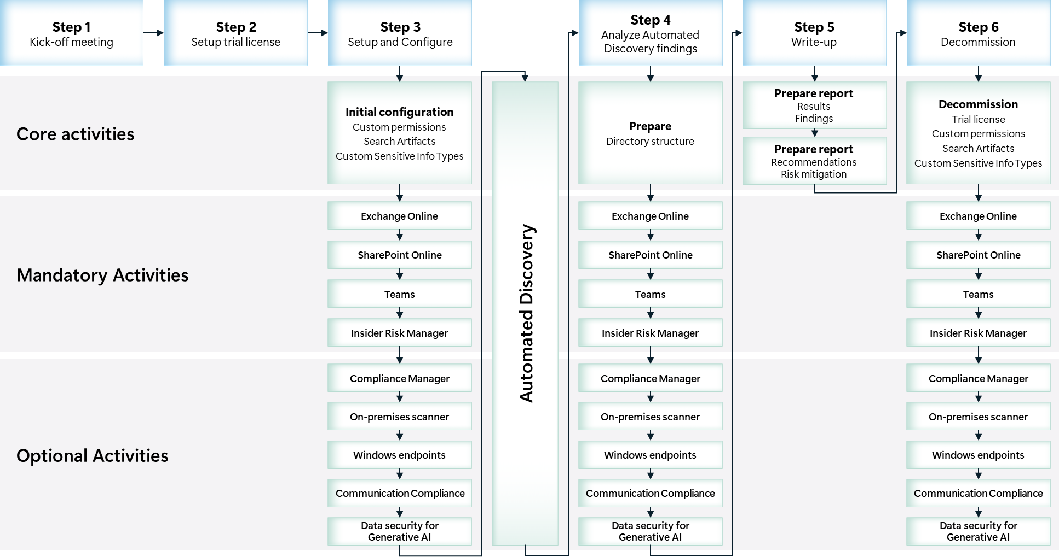

Objectives
The objectives for the Data Security Check are:
- Discover data security risks.
Gain visibility into existing, and at sometimes hidden, data security risks that might exist in the customer’s organizational data.
- Understand how to mitigate identified risks.
Help customers to better understand, prioritize, and mitigate the identified risks across the Microsoft Cloud and optionally on-premises data repositories.
- Provide recommendations and define next steps.

Scoping

In scope
The default Data Security Check scope includes:
- Gain visibility into hidden data security risks in the Microsoft 365 Cloud environment in use by the customer.
- Enable the Automated Discovery service to search for:
  - Data that contains one or more sensitive information types
  - Stale data
  - Suspicious and unusual activities
- Help the customer understand how Microsoft Purview products and services can help mitigate and protect against the data security risks that were identified over the course of the engagement.
- Enable Microsoft 365 services used by the Data Security Check Automated Discovery process:
  - Microsoft Purview eDiscovery
  - Microsoft Purview Data Loss Prevention
  - Microsoft Purview Insider Risk Management
  - Microsoft Purview Information Protection
  - Microsoft Purview Audit
In addition to the default scope, additional Microsoft Purview products and services can be enabled to extend the engagement to include other data repositories and user activities:
  - Microsoft Purview Compliance Manager
  - Microsoft Purview Data Loss Prevention for Endpoints
  - Microsoft Purview Information Protection scanner
  - Microsoft Purview Communication Compliance
  - Microsoft Purview Data Security Posture Management for AI (DSPM for AI)

Out of scope
The standard scope of the engagement excludes:
- Discovery activities for other cloud services. The Data Security Check does not include discovery activities for third-party cloud services such as, but not limited to, AWS, Box, and Google Drive.
- Proof of concept or lab deployment. The standard scope of the Data Security Check does not include deployment of the solution in a development or proof of concept environment.
- Creation of a data labelling taxonomy. The standard scope of the Data Security Check does not include defining and designing a data labeling taxonomy.
- Creation of data retention policies or schedules. The standard scope of the Data Security Check does not include marking any data discovered during the Automated Discovery for retention or deletion.
- Labeling discovered documents or data. The standard scope of the Data Security Check does not include applying labels to data or documents identified during the Automated Discovery.
- Client discovery activities. The Data Security Check standard scope does not include discovery activities that involve client devices such as, but not limited to, workstations, laptops, mobile devices (this can however be added as an optional module).

Customer requirements
Successful delivery of the Data Security Check depends on the customer's involvement in all aspects of the engagement. The customer must ensure that accurate and complete information is provided in a timely fashion, that appropriate resources are committed, and that activities are completed in a timely and effective manner. The customer will need to perform the tasks, provide the resources, and take ownership of following activities:
Note
This section describes the customer requirements applicable to the overall engagement. Additional requirements specific to the activities will be outlined in the individual sections below.

- The customer will need to provide adequate access to the necessary personnel needed to successfully complete the engagement, including:
  - A customer point of contact (such as a Project or Engagement Manager) responsible for the overall coordination and for scheduling logistics.
  - IT object owners for regulatory compliance and security during all phases of the assessment.
  - Executive Sponsor.
- The customer will provide the following to the partner resource:
  - Access to any relevant documentation.
  - Network connectivity, adequate workspace, parking permits, building access, and appropriate identification badges within the first day of the on-site engagement.
  - Appropriate-sized room with whiteboard and projector for knowledge transfer sessions.

Infrastructure requirements
The table below lists the infrastructure and service requirements that must be fulfilled to be able to successfully deliver the Data Security Check.
Component | Description | License Requirements
Microsoft 365 tenant | Customer’s production Microsoft 365 tenant populated with production data and production users. | Any combination of:  - Microsoft E3  - Microsoft E5  - Microsoft Purview suite  Note  If an eligible customer does not have the required licenses, one or more (trial) license(s) will be provided.
Data Security Check (trial) licenses | The Data Security Check licenses will enable all Microsoft Purview products and services used in the Data Security Check activity. | Licenses listed above are pre-requisite for the Data Security Check licenses.  Note  If the customer already has Microsoft 365 E5 licenses, there’s no need to install the provided Data Security Check licenses.

Deliverables
The deliverables for the Data Security Check are defined as:
- Data Security Check findings overview. Lists and interprets data security risks identified by the Automated Discovery process and observed during this activity.
- Data Security Check recommendations. Maps the observed data security risks to Microsoft Purview products and services in order to mitigate impact and improve the organization’s compliance posture.
The findings and recommendations from the Data Security Check will be shared with the customer during the Recommendations and next steps session on the final day of the Data Security Envisioning Workshop. The workshop kit includes two presentation templates to help you build the close-out presentation. The choice of template should be guided by the specific audience you are presenting to.

Note
Depending on the customer’s context, you may choose to deliver a single version of the close-out presentation or schedule two separate sessions: one with the broader team to review all aspects of the engagement in detail, and another with senior management or CxO stakeholders to focus on key findings, recommendations, and next steps..

Refer to the table below for a clear overview of each template and guidance on when to use it."
Presentation template | Description
<41-Close-out deck> | A PowerPoint template that serves as a foundation for the close-out presentation. It is designed to be outcome-focused, summarizing all activities conducted during the Data Security Envisioning Workshop, presenting key findings and identified risks, and outlining actionable recommendations and remediation steps to address those risks.
<42-Close-out deck COMPACT> | A streamlined version of the <41-Close-out deck>, tailored for senior management and CxO audiences. This outcome-driven presentation emphasizes the most critical findings from the Data Security Envisioning Workshop and focuses on key recommendations and next steps—minimizing technical detail and activity-level summaries to maintain strategic relevance.

Automated Discovery tools and services
The Data Security Check Automated Discovery process leverages the following Microsoft 365 features & services that will be enabled and configured to discover and report on data security risks:
- eDiscovery
- Information Protection
- Data Loss Prevention
- Insider Risk Management
- Audit
Additionally, the following Microsoft Purview products and services may be enabled depending on the optional modules decided on by the customer:
- Compliance Manager
- Data Loss Prevention for Endpoints
- Purview Information Protection scanner
- Communication Compliance
- DSPM for AI
For detail and background on the above features & services, refer to the per activity module delivery guides:
- 01-Module Delivery Guide-Exchange
- 02-Module Delivery Guide-SharePoint
- 03-Module Delivery Guide-Teams
- 04-Module Delivery Guide-Insider Risk Discovery
- 05-Module Delivery Guide-Compliance Manager
- 06-Module Delivery Guide-On premises
- 07-Module Delivery Guide-Windows Endpoints
- 08-Module Delivery Guide-Communication Compliance
- 09-Module Delivery Guide-Data Security for AI

Sensitive Info Types
Sensitive Info Types are the artifacts the Data Security Check Automated Discovery process will look for in various Microsoft 365 storage locations such as Exchange Online, OneDrive for Business, and SharePoint Online or when evaluating user behavior, user communication or interaction with generative AI tools (optional). Microsoft 365 comes with over 315 pre-defined Out-of-box Sensitive Info Types that are ready to use by the Automated Discovery process described in this guide. In addition, this guide will describe how to create Custom Sensitive Info Types that meet the customer’s specific needs.
The discovery capabilities of the automated process depend on the storage location, the type of activity and the type of data.
Storage locations
The Automated Discovery works across the following storage locations:
- Exchange Online: Used for mailboxes, public folders, Teams conversations, Viva Engage (Yammer) user messages, and Microsoft 365 group mailboxes.
- SharePoint Online: Used for SharePoint Online sites, OneDrive for Business accounts, Teams sites, Viva Engage (Yammer) networks, and Microsoft 365 Group sites.
- Teams: Used for chat and channel messages, including private channels.
This delivery guide will provide guidance on how to configure the Automated Discovery for both out-of-the-box and custom Sensitive Info Types. The examples provided should be customized to align with your customer’s expectations and requirements. If needed, additional or more complex search queries can be defined and added.

Background information
For more information on Sensitive Info Types, refer to:
- Sensitive information type entity definitions
- Learn about sensitive information types
- Create a search query for a case in eDiscovery
- Use the condition builder to create search queries in eDiscovery

Impact on user experience
The Data Security Check Automated Discovery process will be fully transparent to both the end user and administrator; it will not modify, move, or delete any data:
- eDiscovery will only search for and report on stale data across the Microsoft Cloud in use by the organization; it will not delete, archive, or apply other types of retention policies to the data.
- Data Loss Prevention will only report on data containing the sensitive items configured; it will not send notifications to the end user, prevent sharing, implement encryption, or apply other changes to the data.
- Insider Risk Management will only report on insider risks; it will not send notifications to the end user, prevent sharing, implement encryption, or apply other changes to the data.
- Compliance Manager will only advise and recommend on improvement actions, it will not implement any changes to the customer production environment.
- Data Loss Prevention for Endpoints will only scan for risky behavior on client workstations; it will not block any actions or change the end user experience in any way. Data Loss Prevention for Endpoints will leverage standard Windows 10/11 services and does not require the installation of agents on the user’s workstation.
- Purview Information Protection scanner will only scan for privacy and regulatory risks in on-premises data repositories; the scanner will not apply, modify, or remove labels.
- Communication Compliance will monitor communications for sharing of information that can impose risk or vulnerability to the organization; it will not block any actions or change the end user experience in any way.
- DSPM for AI will only monitor interactions with generative AI applications and report on activities that can impose risk to the organization; it will not block or prevent any interaction with such tools or applications.

 Important
Carefully follow the provided guidance and do not configure additional options or services because they might have an impact on the user experience.

Step 1 - Kick-off meeting

Guidance
Typically, not all members of the team that will engage in the on-site activities have attended the pre-engagement call as described in section 3 Pre-engagement meeting. It’s recommended to start the on-site activities with a short kick-off meeting with all (new) team members to discuss the upcoming engagement, align expectations, and describe the expected outcome. To support this meeting, the <40-Pre-engagement and Kickoff deck> presentation, created for the pre-engagement activity, can be used. This will ensure that all project team members understand the objectives and goals of the engagement.

Objective(s)
The objective for the kick-off meeting is to provide an overview of the engagement and agree on the scope, schedule, and required resources. The meeting objectives are to:
- Introduce the team to the customer and set the stage for the project.
- Introduce the Data Security Envisioning Workshop.
- Describe and discuss upcoming activities.
- Confirm expectations and timelines.
- Allocate resources for each activity.
- Discuss the engagement scope.
- Align on the optional modules that will be added to the scope.
- Discuss the business problem and why the Data Security Check is important.
- Confirm information about the customer’s requirements.
- Define the search criteria for the Automated Discovery.

Deliverable(s)
The deliverables of the kick-off meeting are defined as:
- Confirmed and agreed (updated) delivery schedule and/or attendee list for all Data Security Check activities.
- Agreed list of optional modules that are added to the Data Security Envisioning Workshop scope.
- Agreed search criteria for the Automated Discovery.

Pre-requisites
- The Infrastructure requirements as outlined in section 4.4 are fulfilled.
- The activities outlined in section 3-Pre-engagement meeting are completed.

Preparation
Prior to delivering the kick-off meeting, the partner resource leading the meeting will need to familiarize themself with:
- The Preparation activities in section 3-Pre-engagement meeting.

Supporting materials
- <40-Pre-engagement and Kickoff deck>
Note
The <40-Pre-engagement and Kickoff deck> is used for both the Pre-engagement meeting and the Step 1 - Kick-off meeting. Instructions on how to update the slides are included as hidden slides in the deck.

Guidance
- Additional delivery guidance for the meeting can be found in the speaker notes provided in the <40-Pre-engagement and Kickoff deck> deck.

Additional per module guidance
Refer to Step 1 - Kick-off meeting in the per module delivery guides for additional activities that should be added to the activities described above.
Additional guidance for the mandatory modules:
- 01-Module Delivery Guide-Exchange
- 02-Module Delivery Guide-SharePoint
- 03-Module Delivery Guide-Teams
- 04-Module Delivery Guide-Insider Risk Discovery
Additional guidance for the optional modules:
- 05-Module Delivery Guide-Compliance Manager
- 06-Module Delivery Guide-On premises
- 07-Module Delivery Guide-Windows Endpoints
- 08-Module Delivery Guide-Communication Compliance
- 09-Module Delivery Guide-Data Security for AI

Step 2 - Acquire and assign licenses
Guidance
The Microsoft 365 products and services used by the Data Security Check all require individual licenses. The licenses the customer previously acquired determine if the customer is entitled to use the products that are required for the Data Security Check or if additional trial licenses are required.
Based on the existing licenses the customer owns, one of the following two scenarios is applicable:
- The customer has all the required licenses: No additional action is required; this activity can be skipped.
- The customer does not have all required licenses: Follow the guidance outlined below to obtain and install the required (trial) licenses included as part of the Data Security Envisioning Workshop.

Important
Trial licenses requested as part of the engagement activities may take up to two (2) business days to be provided and require a valid engagement ID. Please request licenses early enough in the delivery cycle to avoid any delays.

The Data Security Envisioning Workshop includes time-limited trial licenses:
- Microsoft 365 E3 (no Teams) for SCI Partner Engagement Trial
- Microsoft Purview Suite for SCI Partner Engagement Trial
Use the flowchart below to determine which trial licenses are required for the Data Security Check activities.
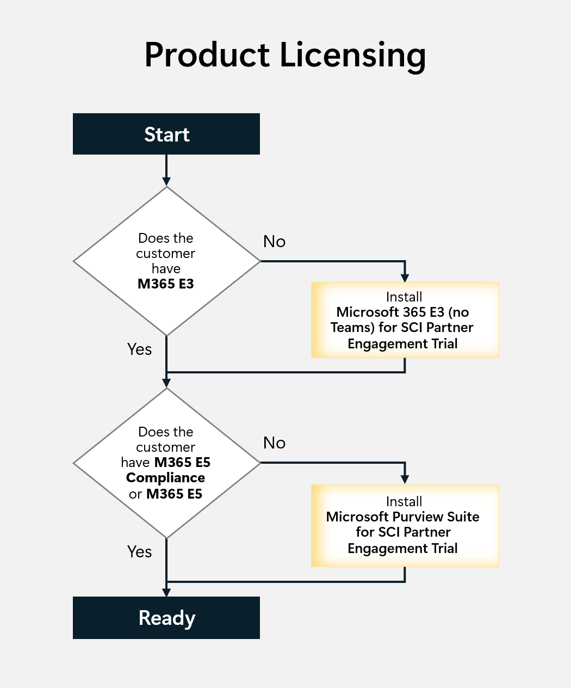
Note
The licenses used to enable the tools and services required by the Data Security Check will be installed in addition to the existing licenses already present in the customer’s production tenant.
The Data Security Check licenses are tailor-made for this activity and will automatically expire after a pre-defined time. The services depending on the Data Security Check trial license will be turned off and/or deprovisioned when the license expires; there will be no impact on the existing production environment.

 Important
The Data Security Check license has a limited number of activations per tenant.

Objective(s)
- Acquire and implement the Data Security Check license that is required for the tools and services used during the engagement.
Deliverable(s)
For this activity, the following deliverables have been defined:
- All tools and services used by the Data Security Check are licensed and ready to be configured.

Pre-requisites
- The activities outlined in paragraph 4.9-Step 1 - Kick-off meeting must be completed prior to starting this activity.
Background reading
For more information refer to:
- Partner Led Customer Trial Guide for Modern Work and Security Engagements

Instructions - Acquire and install the trial licenses
- Browse to the Trial license portal at https://aka.ms/PLGTrialsRequest and obtain the trial licenses required for the Data Security Envisioning Workshop.
- Install the obtained trail licenses in the customers production environment.

Note
For more information and guidance refer to the Partner Led Customer Trial Request Guide available on the trial license portal.

 Important
The Data Security Check license needs to be assigned to all users of the Data Security Check team that will be configuring the Automated Discovery and downloading or exporting the results and findings and the end-users participating in the engagement

Step 3 - Setup and configuration
Data Security Check Automated Discovery leverages the following products / services from the Microsoft Purview product suite to discover privacy and regulatory risks in the customer’s tenant:
- eDiscovery
- Data Loss Prevention
- Insider Risk Management
- Information Protection
Additionally, the customer will choose to enable at least one optional module that requires setup and configuration of one or more of the following products / services:
- Purview Information Protection scanner
- Data Loss Prevention for Endpoints
- Communication Compliance
- Compliance Manager
- DSPM for AI
This section provides initial setup and configuration guidance that is required by all products and services leveraged by the Automated Discovery process. After completing the configuration in this document, refer to the per module delivery guides for additional setup and configuration steps.

Assign Data Security Check team members the required permissions
Guidance
The Data Security Check Automated Discovery process will examine content across Exchange Online, SharePoint Online, OneDrive for Business, and Teams, additionally the discovery process will monitor user activity, communications (optional) and interactions with generative AI applications (optional). The data that the Automated Discovery will scan by nature is sensitive, and at times, (company) confidential or secret. Access to the discovery results and configuring and running the Automated Discovery must therefore be protected and should only be accessible to privileged users.

 Important
Throughout this guide, tenant or enterprise administrator accounts are used when configuring services and assigning permissions. This is done to guarantee a smooth and hassle-free setup and configuration process. However, the use of such accounts does not align with the Least-Privilege Administrative models that most organizations have implemented to allow for granular access control over privileged admin tasks in Microsoft 365.
Wherever possible, you are encouraged to avoid using tenant or enterprise administrator accounts and instead leverage administrative accounts that are configured with just enough access to perform the task at hand. Please refer to the relevant documentation available on Microsoft Learn for further details.

Members of the Data Security Check team who will configure the services required for Automated Discovery need permissions to the Microsoft Purview portal. By default, the tenant admin will have access to this location and can give a Compliance and Risk Officer or other people access to the Microsoft Purview portal, without giving them all the permissions of a tenant admin.
Follow the instructions below to assign the identified users with the required access permissions.
Objective(s)
- Assign Data Security Check team members to appropriate roles in
  - Microsoft Purview
  - Microsoft Exchange Online
  - Microsoft Entra ID
Background reading
For more information refer to:
- Roles and role groups in Microsoft Defender for Office 365 and Microsoft Purview
- Permissions in the Microsoft Purview portal
- Configure permissions filtering for eDiscovery
- Permissions for Data Security Posture Management for AI
Instructions
- Browse to the Microsoft Purview portal at https://purview.microsoft.com/ and log in with your Tenant Admin credentials or an account that is assigned the global admin role.
- In the navigation bar on the left side, click on Settings.
- In the Settings navigator, expand Roles and scopes.
- Below Roles and scopes, click on Role groups.
- On the Role groups for Microsoft Purview Solutions page, search for Compliance Administrator.
- Click on Compliance Administrator.
- On the Compliance Administrator flyout, click Edit.
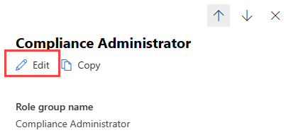
- On the Edit members of the role group page, click on Choose users.
- On the Choose users flyout, select all the Data Security Envisioning Workshop team members that should be assigned the Compliance Administrators role.
- On the Choose users flyout, click Select.
- On the Edit members of the role group page, click Next.
- On the Review the role group and finish page, click Save and then click Done.
- Repeat the above steps for the Compliance Data Administrator role.
- Repeat the above steps for the Organization Management role.
- Repeat the above steps for the eDiscovery Manager role.
- Repeat the above steps for the Content Explorer Content Viewer role.

Note
Assigning users to the Compliance Administrator role group doesn't assign the permissions necessary to fully search the Microsoft 365 audit log or to use any reports that might include Exchange data, such as the Data Loss Prevention or Advanced Threat Protection reports. To search the audit log or to view all reports, a user must also be assigned permissions in Exchange Online. This is because the underlying cmdlet used to search the audit log is an Exchange Online cmdlet. The next steps will describe the steps to add these additional permissions in Exchange.

- Browse to the Microsoft 365 admin center at https://admin.cloud.microsoft and log in with your tenant admin credentials or an account that is assigned the global admin role.
- In the navigation page on the left side, click on …Show all, expand Roles and click on Role Assignments.
- On the Role assignments page, click on the tab for Exchange
- On the Exchange tab, search for Compliance Administrator.
- Click on Compliance Administrator.
- On the Compliance Administrator flyout, select the Assigned tab.
- On the Assigned tab, click on +Add.
- On the Add admins flyout, search for all Members identified during the pre-engagement or kick-off meeting.
- Click Add.
- Click X to close the Compliance Administrator flyout.

Define search artifacts for Automated Discovery
Guidance
This section describes the steps to create Custom Sensitive Info Types that will be used as search artifacts by the Automated Discovery process. The various paragraphs provide sample configurations that need to be updated to align with customer requirements as defined during the pre-engagement or kick-off meeting.

Configure sample Sensitive Info Type: <Customer Sensitive>
Guidance
This section describes the steps to create a sample Sensitive Info Type that will be used to search for specific keywords that are relevant to the customer but are not covered by the Out-of-box Sensitive Info Types included in Microsoft Purview. The guidance below uses <Customer Sensitive> as a placeholder search term; when configuring the sensitive info type, this placeholder must be replaced by a customer relevant search term.
The Sensitive Info Type will use <Customer> as the primary pattern to search for and <Sensitive> as additional evidence. This additional evidence (also known as supporting or corroborative evidence) increases the likelihood that the keyword <Customer> found in the content is really related to <Customer Sensitive>.
Note
Replace the placeholder keywords used in this sample policy with keywords that meet your customer’s requirements as defined in the pre-engagement or kick-off meeting.

Objective(s)
- Configure a sample Sensitive Info Type for <Customer Sensitive>.
Background reading
- For more information refer to Learn about sensitive information types.
Instructions - create the Sensitive Info Type
- Browse to the Microsoft Purview portal at https://purview.microsoft.com/ and log in with Tenant Admin credentials or a user account that is a member of your Data Security Check team and has been assigned the permissions according to the instructions in section 4.11.1.
- In the navigation bar on the left side, click on Solutions.
- In the Solutions navigator, click on Information Protection.
- On the Information Protection solution card, expand Classifiers.
- Below Classifiers, click on Sensitive info types.
- On the Sensitive info types page, click on +Create sensitive info type.
- On the Name your new Sensitive Info Type page, type DataSecurityCheck-CustomerSensitive below Name and provide a meaningful description.
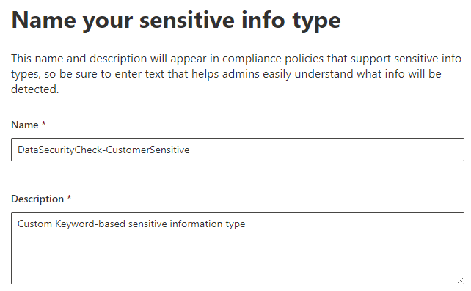
Note
Use the prefix DataSecurityCheck- for all Custom Sensitive Info Types you create, this will improve the search experience when looking for example policies.

- Click Next.
- On the Define patterns for this sensitive info type page, click on +Create pattern.
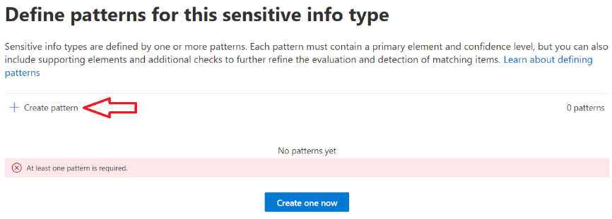
- On the New pattern fly-out, below Confidence level verify the Confidence level is set to High Confidence.

Note
Depending on the type of Sensitive Info Types you are creating you might want to lower the confidence level depending on the number of supporting elements, click i for more information.

- On the New pattern fly-out, below Primary element, click + Add primary element and select Keyword list from the drop-down menu.
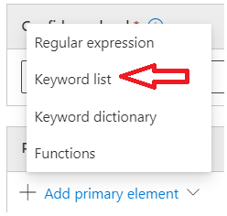
- On the Add a keyword list fly-out, below ID enter DataSecurityCheck-CustomerSensitive.
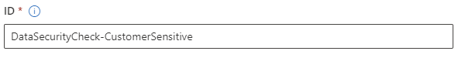
- Below Keyword group #1 - Case insensitive type <Customer>.
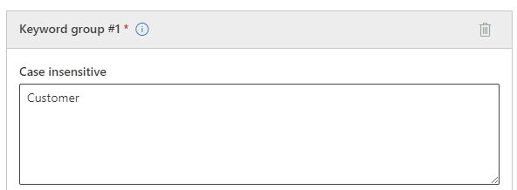

Important
Replace the phrase ‘Customer’ with keywords identified by you and your customer in the planning engagement.

- Verify Word Match is selected.
- Click Done.
- On the New pattern fly-out, below Character proximity, verify proximity is set to 300.
- On the New pattern fly-out, below Supporting elements, click +Add supporting elements or group of elements and select Keyword List from the drop-down menu.
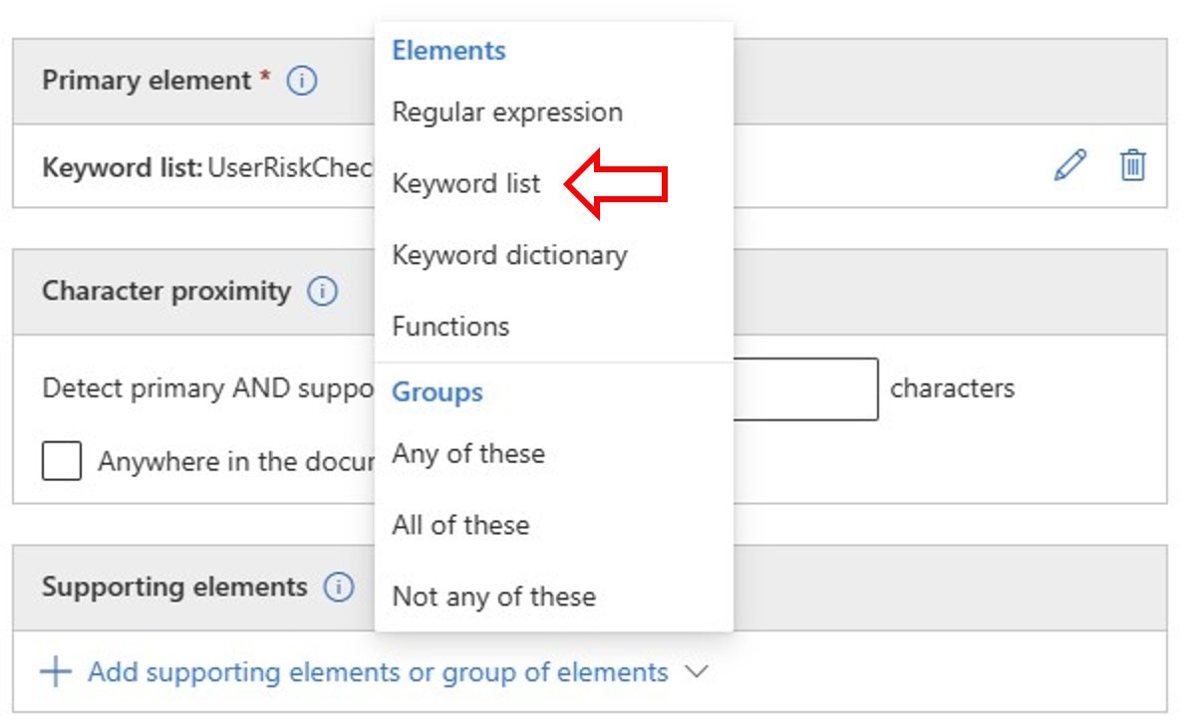
- On the Add a keyword list fly-out, enter DataSecurityCheck-CustomerSensitiveSupport as the ID
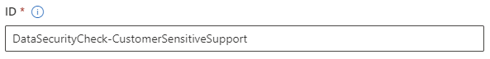
- Below Keyword group #1 - Case insensitive type <Sensitive>
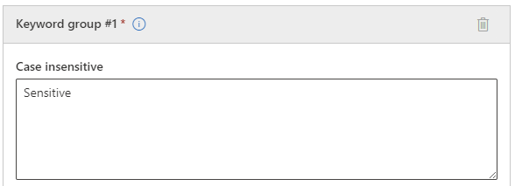

Important
Replace the phrase ‘Sensitive’ with keywords identified by you and your customer in the planning engagement.

- Verify Word Match is selected.
- Click Done.
- Back on the New pattern fly-out, click Create.
- Back on the Define patterns for this sensitive info type page, click Next.
- On the Choose the recommended confidence level to show in compliance policies page, verify High confidence level is selected.

Note
Depending on the type of Sensitive Info Types you are creating you might want to lower the confidence level depending on the number of supporting elements. Click Learn more about confidence levels for additional background information.

- Click Next.
- On the Review settings and finish page, click Create.

Note
While you’re defining the Custom Sensitive Info Types, explore the various configuration options, such as adding additional keywords or the changing the confidence value. They can be used to further optimize the search criteria.

- On the Your sensitive info type is created page, click Done.
- Open Notepad on your local workstation and copy-paste the content below.
Lorem ipsum
Dolor sit amet, consectetur adipiscing elit. Aenean ac elit finibus, blandit augue elementum, porttitor dolor. Ut ornare nec lorem id iaculis. Nulla eu aliquam ligula, non egestas felis. Nunc euismod nisl velit, nec laoreet sapien bibendum a. Donec quis dui ultricies, rutrum ex eu, faucibus dolor. Donec eros arcu, iaculis quis ante eu, fringilla suscipit erat. <Customer Sensitive> Aenean sagittis erat a arcu dictum, mollis hendrerit augue pellentesque. Aliquam pulvinar posuere diam et consequat. Nulla sodales maximus mi vitae sodales. Vestibulum eu velit sapien. Suspendisse potenti. Praesent eget eleifend arcu. Donec ac quam aliquet, dignissim libero ac, pharetra ligula. Duis nec elementum metus. Ut laoreet sodales arcu a cursus.
- Replace the placeholder<Customer Sensitive> with the sensitive information that you identified as relevant to your customer.
- Save the newly created file to your desktop as “Custom Sensitive Info Test.txt”.

Note
When testing in the customer scenario, although you can use the test file as described above, you are advised to use actual production files to test the policies. If possible, try to obtain multiple original documents; this will help you understand if the search logic is working correctly or needs further optimization.

- On the Sensitive info types page, click on the newly created Sensitive info type DataSecurityCheck-CustomerSensitive.
- On the DataSecurityCheck-CustomerSensitive details page, click on Test.
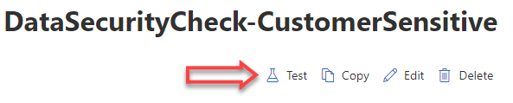
- On the Upload file to test "DataSecurityCheck-CustomerSensitive" page, click on Upload File.
- Select the <Custom Sensitive Info Test.txt> file created in the previous step from your desktop and then click Test.
- When testing is complete, verify there is a match against the sensitive info type you have created.
- Click Finish and the test wizard will close.
- At the top of the DataSecurityCheck-CustomerSensitive page, click on Sensitive info types to return to the Sensitive info types page.

Configure sample Sensitive Info Type: <Employee ID: EMP-123456-NL>
Guidance
This section describes the steps to create a sample Sensitive Info Type that will be used to search for an employee number in a specific format. For this example, we will use an employee number that is defined as: <EMP-nnnnnn-CC>, where <nnnnnn> are six digits in the range 0...9 and <CC> is a two-letter country code.
Note
Replace or update the regular expressions used in this sample search term with a regular expression that meets your customer’s requirements as defined in the pre-engagement or kick-off meeting.

Objective(s)
- Configure a sample Sensitive Info Type for < Employee number: EMP-123456-NL>
Background reading
- For more information refer to Learn about sensitive information types.
- Sensitive information type REGEX validators and additional check
Instructions - create Sensitive Info Type
- Browse to the Microsoft Purview portal at https://purview.microsoft.com/ and log in with Tenant Admin credentials or a user account that is a member of your Data Security Check team and has been assigned the permissions according to the instructions in paragraph 4.11.1.
- In the navigation bar on the left side, click on Solutions.
- In the Solutions navigator, click on Information Protection.
- On the Information Protection solution card, expand Classifiers.
- Below Classifiers, click on Sensitive info types.
- On the Sensitive info types page click on +Create sensitive info type.
- On the Name your new Sensitive Info Type page, type DataSecurityCheck-EmployeeIDs below Name and provide a meaningful description.
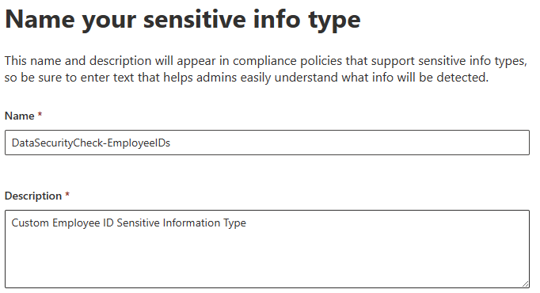
Note
Use the prefix DataSecurityCheck- for all Custom Sensitive Info Types you create, this will improve the search experience when looking for example policies.

- Click Next.
- On the Define patterns for this sensitive info type page, click on +Create pattern.
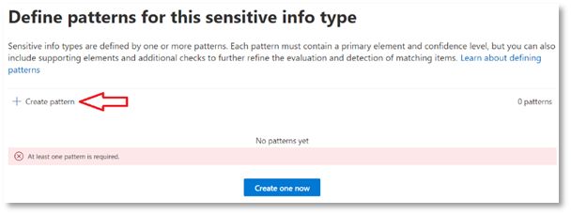
- On New pattern fly-out, below Confidence level verify the Confidence level is set to High Confidence.

Note
Depending on the type of Sensitive Info Types you are creating you might want to lower the confidence level depending on the number of supporting elements; click i for more information.

- On New pattern fly-out, below Primary element, click + Add primary element and select Regular expression from the drop-down menu.
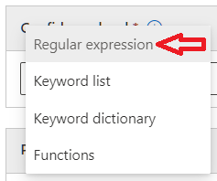
- On Add a regular expression fly-out, enter DataSecurityCheck-EmployeeIDRegEx as the ID
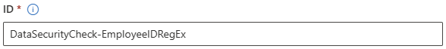
- Below Regular expression type EMP-[0-9]{6}-[A-Z]{2}, verify String match is selected.
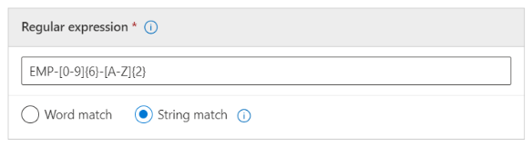
Note
The REGEX pattern EMP-[0-9]{6}-[A-Z]{2} configures the DataSecurityCheck-EmployeeID Sensitive Info Type to match EMP, followed by a dash, 6 digits, a dash and a 2 letter code (e.g. EMP-110234-NL).
More information on regular expressions can be found at Regular Expression Language - Quick Reference.

- Click Done.
- Back on New pattern fly-out, click Create.
- Back on Define patterns for this sensitive info type page, click Next.
- On Choose the recommended confidence level to show in compliance policies page, verify High confidence level is selected.

Note
Depending on the type of Sensitive Info Types you are creating you might want to lower the confidence level depending on the number of supporting elements; click Learn more about confidence levels for additional background information.

- Click Next.
- On Review settings and finish page, click Create.

Note
While you’re defining the Custom Sensitive Info Types, explore the various configuration options, such as adding additional keywords or the changing the confidence value. They can be used to further optimize the search criteria.

- On the Your sensitive info type is created page, click Done.
- Open Notepad on your local workstation and copy-paste the content below.
Adele Vance EMP-110234-NL
Alex Wilber 883909
Allan DeYoung EMP-536319-BE
Bianca Pisani US-123-RUS

Note
When testing in the customer scenario, you are advised to use actual production files to test the policies. If possible, try to obtain multiple original documents. This will help you understand if the search logic is working correctly or needs further optimization.

- Save the newly created file to your desktop as Test Employee Numbers.txt.
- On the Sensitive info types page, click on the newly created Sensitive info type DataSecurityCheck- EmployeeIDs.
- On the DataSecurityCheck-EmployeeIDs page, click on Test.
- On the Upload file to test "DataSecurityCheck-EmployeeIDs" page, click on Upload File.
- Select the <Test Employee Numbers.txt> file created in the previous step from your desktop and then click Test.
- When testing is complete, verify there is a match against the sensitive info type you have created.
- Click Finish and the test wizard will close.
- At the top of the DataSecurityCheck-EmployeeIDs page, click on Sensitive info types to return to the Sensitive info types page.

Turn on audit log recording for user and admin activities
Guidance
Microsoft 365 auditing solutions provide an integrated solution to help organizations effectively respond to security events, forensic investigations, internal investigations, and compliance obligations. Thousands of user and admin operations performed in dozens of Microsoft 365 services and solutions are captured, recorded, and retained in the unified audit log. Audit records for these events are searchable by security ops, IT admins, insider risk teams, and compliance and legal investigators in the organization.
Audit logging is turned on by default for recently created Microsoft 365 and Office 365 enterprise organizations. This paragraph will provide guidance on how to verify audit logging is turned on and, in case it is not yet enabled, provide the necessary steps to enable it.
Objective(s)
- Verify audit logging is enabled.
- Enable audit logging for the tenants that are not enabled by default.
Background reading
- Turn auditing on or off
- Turn on auditing
Instructions – enable audit logging if not enabled
- Browse to the Microsoft Purview portal at https://purview.microsoft.com/ and log in with your Tenant Admin credentials or a user account that is a member of your Data Security Check team and has been assigned the appropriate permissions according to the instructions in paragraph 4.12.1.
- In the navigation bar on the left side, click on Solutions.
- In the Solutions navigator, click on Audit.
If auditing is not turned on, a banner is displayed prompting you to start recording user and admin activity.
- Click Start recording user and admin activity.
- Click Yes on the Complete organizational setup pop up window.
Note
It may take up to 60 minutes before Audit logging is enabled.

Verify audit logging is turned on
- Browse to the Microsoft Purview portal at https://purview.microsoft.com/ and log in with Tenant Admin credentials or a user account that is a member of your Data Security Check team and has been assigned the permissions according to the instructions in paragraph 4.11.1.
- In the navigation bar on the left side, click on Solutions.
- In the Solutions navigator, click on Audit.
- The blue banner should no longer appear on the audit page.

Create eDiscovery Case
Guidance
This section outlines the process to create an eDiscovery case, that will serve as the foundation for building the eDiscovery Searches used by the Automated Discovery process. This paragraph details the key activities that must be completed before proceeding with the creation of searches in the following modules.
Objective(s)
- Create an eDiscovery Case for Automated Discovery
Background reading
- Create and manage cases in eDiscovery
Instructions – Create an eDiscovery case
- Browse to the Microsoft Purview portal at https://purview.microsoft.com/ and log in with Tenant Admin credentials or a user account that is a member of your Data Security Check team and has been assigned the appropriate permissions.
- In the navigations bar on the left-hand side, click on Solutions.
- In the Solutions navigator click on eDiscovery.
- In the navigations bar on the left-hand side, click on Cases.
- On the eDiscovery solution card, click on Cases.
- On the Cases page, click Create case.
- Name your new case DataSecurityCheck-Case.
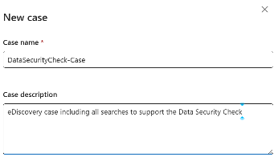
- Click Create.
- On the DataSecurityCheck-Case page, click Case Settings in the upper right.
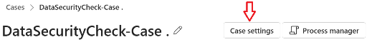
- On the Case Settings page, click Permissions in the menu on the left.
- Under Users, click +Add.
- In the Add members flyout, select all members of the Data Risk Check team.
- Click Add.
- Close the Case Settings page and return to the DataSecurityCheck-Case page DataSecurityCheck-Case page by clicking X in the top right corner.

Additional per module guidance
Each individual Data Security Check module requires additional configuration steps that can be found in the individual module delivery guides. Before continuing with Step 4 - Analyze the findings, first complete the configuration steps in the individual guides.
Refer to Step 3 - Setup and configuration in the per module delivery guides for additional activities that should be added to the activities described above.
Additional guidance for the mandatory modules:
- 01-Module Delivery Guide-Exchange, Step 3 - Setup and configuration
- 02-Module Delivery Guide-SharePoint, Step 3 - Setup and configuration
- 03-Module Delivery Guide-Teams, Step 3 - Setup and configuration
- 04-Module Delivery Guide-Insider Risk Discovery, Step 3 - Setup and configuration
Additional guidance for the optional modules:
- 05-Module Delivery Guide-Compliance Manager, Step 3 - Setup and configuration
- 06-Module Delivery Guide-On premises, Step 3 - Setup and configuration
- 07-Module Delivery Guide-Windows Endpoints, Step 3 - Setup and configuration
- 08-Module Delivery Guide-Communication Compliance , Step 3 - Setup and configuration
- 09-Module Delivery Guide-Data Security for AI , Step 3 - Setup and configuration
Once all activities in Step 3 - Setup and configuration are completed, the automated discovery will run for several weeks (at least 2 is recommended) to identify data security risks in the customer’s environment.

Important
Do not continue with Step 4 - Analyze the findings until the Automated Discovery has run for at least 2 weeks.

Step 4 - Analyze the findings
Guidance
The Automated Discovery process will log findings to several reports and log files. To prepare for analysis, the reports and logs must be downloaded and made available. The following paragraphs provide step-by-step instructions on how to export and download the files needed and how to create screenshots, pivot tables, and other illustrations that can be used to visualize the findings during the close-out presentation.
 Important
The time needed for exporting reports and log files depends on the number of issues identified by the Automated Discovery process. It is recommended to perform the instructions in this section at least one day prior to analysis activities.

Once the reports and log files are collected and stored in the newly created local folders, the analysis of the findings can begin. It is recommended to start the analysis process by looking at the various dashboards available from the Microsoft Purview portal. These dashboards will provide high-level insights into the findings and allow you to quickly identify trends and high-impact risks.

What to look for in reports generated by the Automated Discovery process
The Data Security Check focuses on identifying data security risks related to organizational data and risky user activities. We expect Automated Discovery to identify risks related to:
- Personally Identifiable Information (PII), such as passport numbers, social security numbers, social insurance numbers, health service numbers, or taxpayer numbers.
- Financial data, such as bank accounts numbers or credit cards.
- Custom specific sensitive data, defined specifically for the customer, such as employee records, salary information, record updates, confidential projects or documents, product specifications, or company IP.
- User behaviors, such as the improper handling of sensitive information, accidental (or deliberate) leakage or destruction of data, or inappropriate, harmful, or unauthorized communications.
- Interaction with generative AI applications, such as access to Microsoft 365 Copilot and/or third-party generative AI websites and the use of unmanaged or unsanctioned third-party generative AI websites.
The Automated Discovery looks sensitive data types that are:
- Stored in:
  - Exchange Online
  - SharePoint Online
  - OneDrive for Business
- Sent over email connections to other recipients.
- Stored in locations that are shared with external organizations/people.
- Processed on Windows Endpoints.
- Sent as Microsoft Teams chat and channel messages, including private channel messages.
- Shared with generative AI applications.
Note
The Automated Discovery findings will contain personal identifiable and sensitive corporate information. Organizations may request to first do an internal analysis before handing the information over for further investigation. This internal analysis will have an impact on the duration of the engagement, and if needed, planning should be updated accordingly.

Instructions – create central repository
To easily find and identify the exported reports and log files, a directory structure will be created on the local workstation or network share.
- On the local workstation or on a centralized network share, create the directory structure outlined below:
1 \DataSecurityCheck\ExchangeOnline
1 \DataSecurityCheck\SharePointOnline
1 \DataSecurityCheck\Teams
1 \DataSecurityCheck\InsiderRiskManagement
- Optionally, depending on the included modules, add:
1 \DataSecurityCheck\ComplianceManager
1 \DataSecurityCheck\PurviewScanner
1 \DataSecurityCheck\EndpointDLP
1 \DataSecurityCheck\CommunicationCompliance
1 \DataSecurityCheck\DSPMForAI

Additional, per module guidance
Each individual Data Security Check module requires additional steps to analyze the identified risks. These additional steps can be found in the individual module delivery guides. Before continuing with Step 5 - Report and recommendations write-up, first complete the activities for Step 4 - Analyze the findings in the individual module delivery guides.
Refer to Step 4 - Analyze the findings in the per module delivery guides for additional activities that should be added to the activities described above.
Additional guidance for the mandatory modules:
- 01-Module Delivery Guide-Exchange
- 02-Module Delivery Guide-SharePoint
- 03-Module Delivery Guide-Teams
- 04-Module Delivery Guide-Insider Risk Discovery
Additional guidance for the optional modules:
- 05-Module Delivery Guide-Compliance Manager
- 06-Module Delivery Guide-On premises
- 07-Module Delivery Guide-Windows Endpoints
- 08-Module Delivery Guide-Communication Compliance
- 09-Module Delivery Guide-Data Security for AI

Important
Do not continue with Step 5 - Report and recommendations write-up until you have completed all activities described in the module delivery guides listed above.

Step 5 - Report and recommendations write-up
The findings from the previous activities will be summarized and documented in a presentation that will be used during the closeout session for the Data Security Envisioning Workshop. This presentation will focus on the most important and impactful data security risks that were discovered by the Data Security Check Automated Discovery process. Additionally, it will also provide recommendations to mitigate and prevent threats.
The Data Security Envisioning Workshop kit comes with a pre-populated presentation template that includes an introduction to the Data Security Check activity, an overview of the Automated Discovery process, and placeholders for the findings and recommendations. This template is intended to be used as a starting point and should be customized prior to delivery.

Results and Findings report
Guidance
This activity focuses on updating the closeout presentation template with the information and screenshots showing the most impactful and visible privacy and regulatory risks that were discovered by the Data Security Check Automated Discovery process.
Objective(s)
The objectives for this activity are:
- Update the “Results and Findings” section of the closeout presentation with the data security risks identified by the Automated Discovery process.
Deliverable(s)
For this activity, the following deliverables have been defined:
- Section “Results and Findings” in the closeout presentation updated with the information from the various reports and logs, clearly calling out the data security risks identified by the Automated Discovery process.
Pre-requisites
- The activities outlined in the previous paragraph must be completed prior to starting this activity.
Supporting materials
- <41-Close-out deck>
- <42-Close-out deck COMPACT>
Instructions
- Customize and update the Results and Findings section in the <41-Close-out deck> and/or the <42-Close-out deck COMPACT> with the analysis results and saved screenshots created in the previous paragraph.
- Additional guidance can be found in the speaker notes and hidden slides of the <41-Close-out deck> and the <42-Close-out deck COMPACT>.

 Important
Discuss with the customer if and how much Personally Identifiable Information (PII) is allowed to be revealed in the closeout presentation. When in doubt, obfuscate all information that could reveal user identity or information type.

Recommendations for risk mitigation
Guidance
This activity focuses on updating the closeout presentation template with recommendations to improve the overall data security and compliance posture of the organization by addressing issues that currently are not being detected or that go by unnoticed.
Objective(s)
The objectives for this activity are:
- Update the “Recommendations” section of the closeout presentation with recommendations on how to mitigate the risks identified by the Data Security Check Automated Discovery process.
- Provide a list of actionable next steps plotted on a timeline.
Deliverable(s)
For this activity, the following deliverables have been defined:
- Section “Recommendations” in the closeout presentation updated with recommendations and actionable next steps to mitigate and control the data security risks identified by the Automated Discovery process. .
Pre-requisites
- The activities outlined in the previous sections must be completed prior to starting this activity.
Supporting materials
- <41-Close-out deck>
- <42-Close-out deck COMPACT>
Instructions
- Customize and update the Recommendations section in the <41-Close-out deck> and/or the <42-Close-out deck COMPACT> with recommendations for products and procedures to mitigate the data security risks identified.
- Additional guidance can be found in the speaker notes and hidden slides of the <41-Close-out deck> and the <42-Close-out deck COMPACT>.

Step 6 - Decommission
Guidance
The final activity for the Data Security Check activity is to decommission the services and tools used and to remove the time-constrained Data Security Check licenses from the customer’s production tenant.

Objective(s)
The objectives for this activity are:
- Decommission the services that were installed to support the Data Security Check activity.
- Remove all Data Security Check custom configuration artifacts.
- Remove the Data Security Check licenses that were applied to support the engagement.
Deliverable(s)
For this activity, the following deliverables have been defined:
- All tools and services used during the Data Security Check activity are decommissioned.
- All custom configuration artifacts are removed.
- All licenses used during the Data Security Check activity are decommissioned.
Additional, per module guidance
Each individual Data Security Check module requires specific decommission steps to uninstall and remove the Data Security Check configuration. These additional steps can be found in the individual module delivery guides. Before continuing with the generic decommissioning activities outlined below, first complete the activities for Step 5 - Report and recommendations write-up in the individual module delivery guides.
Refer to Step 6 - Decommission in the per module delivery guides for additional activities that should be added to the activities described below.
Additional guidance for the mandatory modules:
- 01-Module Delivery Guide-Exchange
- 02-Module Delivery Guide-SharePoint
- 03-Module Delivery Guide-Teams
- 04-Module Delivery Guide-Insider Risk Discovery
Additional guidance for the optional modules:
- 05-Module Delivery Guide-Compliance Manager
- 06-Module Delivery Guide-On premises
- 07-Module Delivery Guide-Windows Endpoints
- 08-Module Delivery Guide-Communication Compliance
- 09-Module Delivery Guide-Data Security for AI

Instructions – Delete eDiscovery Case
- Browse to the Microsoft Purview portal at https://purview.microsoft.com/ and log in with Tenant Admin credentials or a user account that is a member of your Data Security Check team and has been assigned the appropriate permissions.
- In the navigation bar on the left side, click on Solutions.
- In the Solutions navigator, click on eDiscovery.
- On the eDiscovery solution card, click on Cases.
- On the Cases page, click on the ellipsis () next to DataSecurityCheck-Case and click on Delete case.
- On the Warning pop-up window, click on Yes.

Important
Deleting an eDiscovery case will permanently remove all associated searches, not just those created within this module. If you still need access to any of the other searches, do not delete the case.

Instructions – Delete Custom Sensitive Info Types
- Browse to the Microsoft Purview portal at https://purview.microsoft.com/ and log in with Tenant Admin credentials or a user account that is a member of your Data Security Check team and has been assigned the permissions according to the instructions in paragraph 4.11.1.
- In the navigation bar on the left side, click on Solutions.
- In the Solutions navigator, click on Information Protection.
- On the Information Protection solution card, expand Classifiers.
- Below Classifiers, click on Sensitive info types.
- On the Sensitive info types page, search for DataSecurityCheck-.
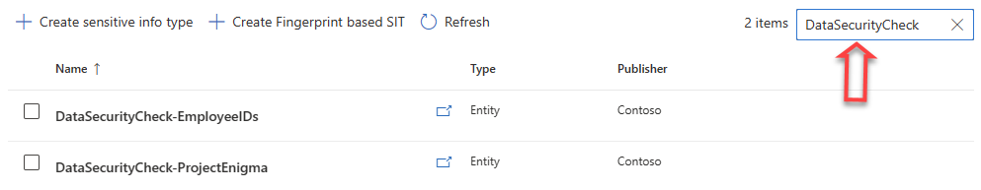
- One by one, click on the Sensitive info types created in paragraph 4.11.2-Define search artifacts for Automated Discovery.
- On the <DataSecuritCheck-name> page, click Delete.
- On the warning page, click Yes.
- Repeat the above steps to delete all Sensitive info types created in paragraph 4.11.2-Define search artifacts for Automated Discovery.
Instructions – Remove role assignments for the Data Security Check team members
- Browse to the https://purview.microsoft.com/ and log in with your Tenant Admin credentials or an account that is assigned the global admin role.
- In the navigation bar on the left side, click on Settings.
- On the Settings card, expand Roles and scopes.
- Below Roles and scopes, click on Role groups.
- On the Role groups for Microsoft Purview Solutions page, search for Compliance Administrator.
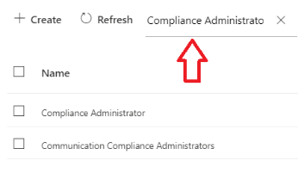
- Click on Compliance Administrator.
- On the Compliance Administrator flyout, click Edit.
- On the Edit members of the role group page, select all the Data Security Envisioning Workshop team members that were assigned the Compliance Manager Administrators role.
- Click on Remove members.
- Click Next.
- On the Review the role group and finish page, click Save.
- Click Done.
- Repeat the above steps for the Compliance Data Administrator role.
- Repeat the above steps for the Organization Management role.
- Repeat the above steps for the eDiscovery Manager role.
- Repeat the above steps for the Content Explorer Content Viewer role.
Instructions – Remove users from Exchange admin roles
- Browse to the Microsoft Purview portal at https://portal.microsoft.com/ and log in with your tenant admin credentials or an account that is assigned the global admin role.
- In the navigation page on the left side, expand Roles and click on Role Assignments.
- On the Role assignments page, click on the tab for Exchange
- On the Exchange tab, search for Compliance Administrator.
- Click on Compliance Administrator.
- On the Compliance Administrator fly-out, select the Assigned tab.
- Select all the Data Security Envisioning Workshop team members that were assigned the Compliance Management admin role.
- Click Delete.
- Click Yes, Remove.
- Click x to close the flyout.
Instructions – Disable the Data Security Check licenses
- Browse to the https://admin.microsoft.com/ and log in with your Tenant Admin credentials.
- On the left-side menu, expand Billing and then click Your Products.
- Select the trial licenses for the Data Security Check that were added in paragraph 4.10.
- Click Cancel subscription.
- On the Cancel subscription fly out, click Cancel subscription.

Microsoft Purview portfolio overview
Guidance
In this session the partner resource will introduce the customer to the Microsoft Purview vision and outline Microsoft’s approach to providing integrated protection and risk mitigation.
Objective(s)
The objectives for this session are to:
- Familiarize the customer with the Microsoft Purview vision.
- Introduce the customer to the Microsoft Purview portfolio of products.
Deliverable(s)
- Microsoft Purview vision pitch delivered to the customer audience.
Pre-requisites
- Both the mandatory modules as well as the optional modules that were additionally added to the Data Security Envisioning Workshop must be completed successfully.

 Important
Use the (preliminary) results and findings from the Data Security Check to deliver a tailor-made vision pitch that aligns with the customer’s challenges.

Preparation
Prior to the delivery of this session, the partner resources should:
- Familiarize themselves with the Microsoft Purview vision as outlined in the deck(s) referenced in the Supporting materials section.
- Gain a good understanding of the Microsoft Purview portfolio of products.
- Familiarize themselves with the product demos.
- Make an inventory of the licenses currently in use by the customer and explore options to include additional Microsoft Purview products and services that will help the customer improve their compliance posture.
Supporting materials
- Supporting materials and decks can be found under Resources in the Product and solution presentations section at https://aka.ms/DataSecurityEnvisioningWorkshop/SupportingContent.
- Product demos can be found at Microsoft Customer Digital Experiences (demos.microsoft.com).
Instructions
When delivering the Microsoft Purview vision pitch, avoid taking a generic approach. Customize the story to align with the customer’s needs and requirements around data security, regulatory compliance, and data privacy. Use the findings from the Data Security Check Automated Discovery process to tailor the presentation(s) to the customer’s situation.
For this activity, at a minimum, the following presentations from the supporting presentations must be delivered to the customer:
- Microsoft Purview Overview
- Microsoft Purview E5 Compliance Value
If customers are interested in learning more about how specific Microsoft solutions can help mitigate the data security risks that were identified by the Data Security Check Automated Discovery process, the partner can optionally choose to deliver one or more product presentations and demos. The table below provides content suggestions related to the identified risks.

Identified risks or scenario | Product presentations | Product demos or interactive guides
Stale data | - Microsoft Purview Data Lifecycle Management Overview  - Microsoft Purview Information Protection Overview  - Microsoft Purview Records Management Overview | - Mitigate Risks & Reduce Costs with Data Governance - Demo Tenant  - Microsoft Purview Records Management - Demo Tenant  - Microsoft Purview Data Lifecycle and Records Management - Simulated Demo
Unprotected sensitive data | - Microsoft Purview Data Loss Prevention Overview  - Microsoft Purview Information Protection Overview | - Microsoft Data Loss Prevention - Demo Tenant  - Microsoft Endpoint DLP - Simulated Demo  - Protect sensitive data with MIP - Simulated Demo  - Discover data shared with AI Applications - Interactive Demo
IP theft  Security or regulatory compliance violations  Sensitive Data leaks | - Microsoft Purview Insider Risk Management Overview  - Microsoft Purview eDiscovery (Premium)  - Microsoft Purview Audit Overview | - Microsoft Purview Data Security Demo  - Microsoft Purview eDiscovery (Premium)  - Microsoft Purview Audit for forensic investigation - Simulated Demo –  - Minimize internal risks with Insider Risk Management - Simulated Demo  - Protection from data leaks and data theft - Interactive Demo
Workplace violence  Workplace harassment  Conflicts of interest  Policy violations | - Microsoft Purview Communication Compliance Overview  - Microsoft Purview eDiscovery (Premium) | - Microsoft Communication Compliance Demo Tenant
Data overexposure  Data transfer | - Microsoft Priva Privacy Risk Management  - Secure and govern Microsoft 365 Copilot Customer Pitch Deck | - Microsoft Priva - Demo Tenant  - Address oversharing concerns in Microsoft 365 Copilot deployment blueprint
Regulatory obligations | - Microsoft Purview Compliance Manager Overview | - Simplify compliance with Compliance Manager - Demo Tenant  - Govern emerging AI regulations w/ Purview - Interactive Demo
End-to-end data security | - Data Security Customer Pitch Deck  - Secure AI Transformation  - Microsoft Data Security Posture Management  - Secure and govern your data with Microsoft Fabric and Purview | - Microsoft Purview Data Security Demo - Demo Tenant  - Protect sensitive data in AI journey with Purview - Interactive Demo  - Discover data shared with AI applications - Interactive Demo
Investigating data security risks using AI | - Microsoft Security Copilot in Purview |  | - Purview & Copilot - in Insider Risk Management - Interactive Demo  - Purview & Copilot in Communication Compliance - Interactive Demo

Note
All presentation decks listed above can be found under <Product and Solution Presentations> in the <Resources> section at https://aka.ms/DataSecurityEnvisioningWorkshop/SupportingContent.
You are advised to check for updates and new content prior to the delivery of the Microsoft Purview portfolio overview.

Recommendations and next steps
Guidance
The findings and risks that were identified by the Data Security Check are mapped to products and services from the Microsoft Purview portfolio that can help mitigate and control them. At the end of the Data Security Envisioning Workshop this mapping will be discussed, and actionable next steps will be defined and presented.

Objective(s)
The objectives for this activity are:
- Present Recommendations and next steps using the <41-Close-out deck> and/or the <42-Close-out deck COMPACT>.
Deliverable(s)
For this activity, the following deliverables have been defined:
- Present the <41-Close-out deck> and/or the <42-Close-out deck COMPACT>.
Pre-requisites
- The activities described in the previous paragraph must be completed prior to starting this activity.
Preparation
Prior to delivering this activity, the partner resource will need to:
- Familiarize themself with the updated content of the <41-Close-out deck> and/or the <42-Close-out deck COMPACT>.
Supporting materials
- <41-Close-out deck>
- <42-Close-out deck COMPACT>
Instructions
- Delivery guidance for this session can be found in the speaker notes and hidden slides of the <41-Close-out deck> and/or the <42-Close-out deck COMPACT>.

- Formatting CSV files in Excel
Guidance
Reports downloaded as comma separated (CSV) files can be opened in Microsoft Excel. Follow the instructions below to import the report and format the data as a table that can be used for further processing.
Instructions
- Open Microsoft Excel.
- On the Data ribbon, in the Get & Transform Data section, click on From Text/CSV.
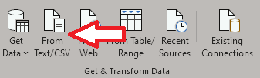
- Browse to the downloaded report and click Import.
- Verify the formatting of the imported data is correct. If needed, change the Delimiter to Comma.
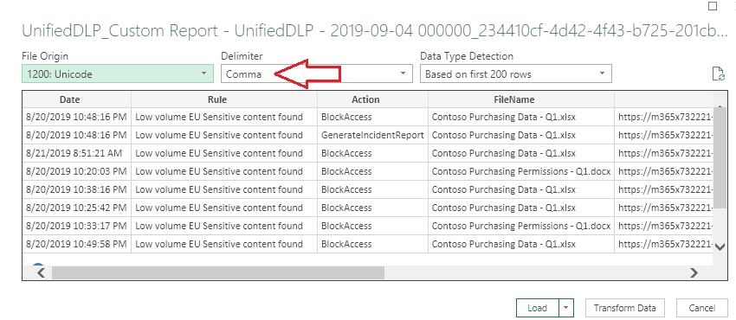
- Click Load.

- The exported report will now be loaded into Excel. You can use the column filters to sort and filter the rows to further investigate the identified spikes, trends, and other points of interest.
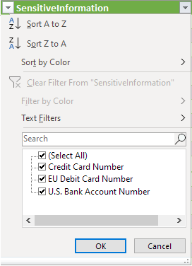

Configurable to customer preference.
This activity can be part of the Pre-engagement meeting or the kick-off meeting, depending on the customer’s preference.
Depending on customer/partner preference, this deliverable can also be part of the kick-off meeting.
This activity can be part of the Pre-engagement meeting or the kick-off meeting, depending on the preference of the customer.
Depending on customer/partner preference, this deliverable can also be part of the kick-off meeting.

